**Schema diagrams 7**

**Relational Algebra 8**

**PostgreSQL Intro 13**

**Data Management 16**

**PostgreSQL 16**

**SQL Joins 21**

**Nested queries 22**

**Adding new rows 23**

**Modifying rows 23**

**Data integrity constraints 23**

**Normalization 27**

**Normal Forms 28**

**Other Data Management Systems 31**

**Big Data 37**

**Map-Reduce 37**

**Spark 39**

**Streaming systems 41**

**Processing streaming data 43**

**NoSQL 44**

**Data storage 47**

**Query processing 52**

**Transactions 55**

**For exams: 61**

**Extra homework stuff 62**

**Redis Demo 66**

**MongoDB Demo 68**

**Neo4j Cypher Demo 72**

Problems with using flat files:

* data integrity and redundancy
* sysadmin is the bottleneck
* lack of atomicity
* concurrent access
* security

Database: abstracts away how data is stored, maintained, and processed

* big data and distributed systems have reintroduced the importance of understanding how data is laid out on disks/nodes

A database:

* Provides way to Create, Read, Update, Delete (CRUD) data without worrying about files and breaking data integrity
* provides one single location for all data in the database
* is little more than specialized data structures on disk/SSD, some NoSQL systems like ReDiS (Remote Dictionary Server) are called “data structure servers”
  + Data structures: hash tables, trees

Database-like systems:

* blockchain is similar to distributed database, where each participant maintains their own data and updates to the database. All nodes in the system cooperate to make sure the database comes to the same conclusion, a form of security
  + network of users acts as a consensus mechanism
* git: stupid content tracker–git can be used to track any kind of content

Levels of abstraction:

* physical: how data is stored on disk and accessed
* logical: how we read and write data
* view: use case specific

Logical abstraction:

* way of abstracting a structured type–describes what data is in the database and how they are represented, as well as relationships among data
  + e.g.

struct Section {

int srs;

int cap;

int instructor_uid;

int parent_srs;

}

View level abstraction:

* highest level of abstraction–provides only the data needed for a particular use case
  + e.g. given instructor data, an email directory use case only requires name and email, not all instructor data such as UID and SSN
* The information stored in a database at a particular point of tim eis called an **instance** (some state of a database)
* **Schema**: overall design of a database
  + logical structure of a database or a relation
* **Data model**: defines how we design databases or interact with data
  + How do we define data?
  + How do we encode relationships among data?
  + How do we impose constraints on data? (e,g, data types, data integrity)
  + 5 major types of models based on implementation (actually how data is stored on disk) and design mechanisms (abstraction for how data is stored)
    - **relational (implementation)**: data stored as a relation. Rows (records) represent individual units called tuples, columns represent attributes common to all records and have specific types
      * e.g. MySQL, PostgreSQL, SQlite, Oracle, MS SQLServer, DB2
    - **entity-relationship (ER) (design mechanism)**: uses a collection of basic objects called entities and relationships among them. WE typically use this to visualize a database design
      * 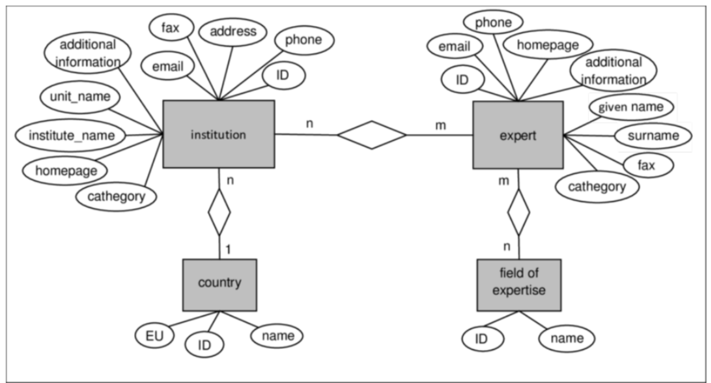
      * explicit cardinality
      * relationships are explicitly defined
    - **object-oriented (design mechanism)**: draws a strong analogy to object-oriented programming with encapsulation, methods, object identity
      * ORM: object relational model
        + e.g. Django, SQLAlchemy, PHP Laravel
    - **document/semi-structured (implementation?)**: individual data objects may have different sets of attributes:
      * records may not share a core set of attributes, each record can have its own attributes
      * JSON and XML are two examples of data types for semi-structured model
      * e.g. MongoDB, Firebase, DynamoDB, CouchDB
    - **network/hierarchical/graph (implementation)**: defines records as nodes, and relationships between records as edges
      * e.g. Neptune, OrientDB, neo4j
      * 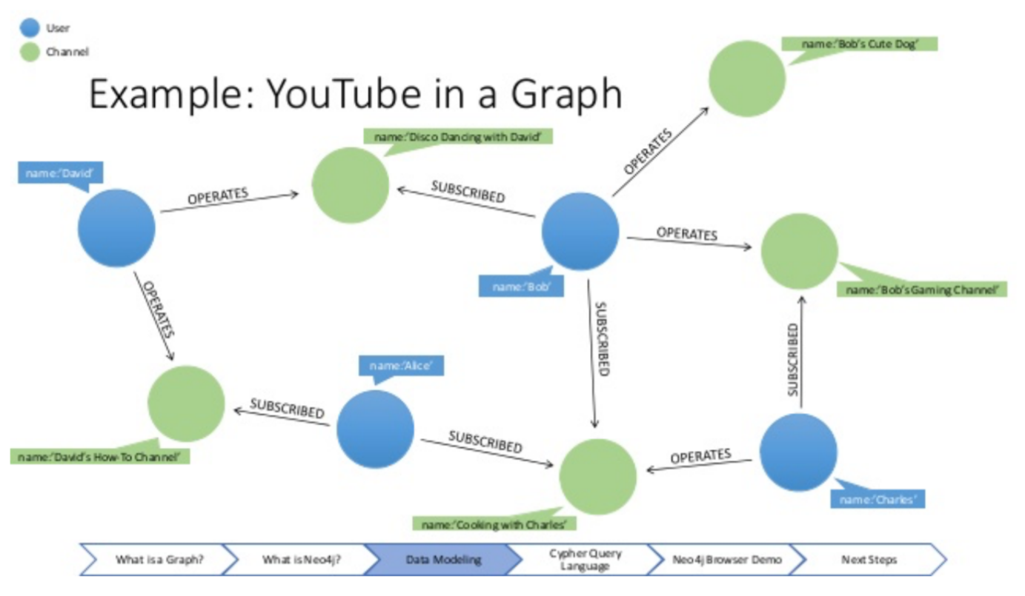
      * can be directed or undirected depending on situation and privacy requirements
      * graph query languages: Cypher, GQL, Gremlin,

Database languages:

* Data definition language (DDL): create/delete objects
* Data manipulation language (DML): CRUD
* For relational databases, both DDL and DML are SQL

Data manipulation language

* Two types:
  + **Procedural**: user specifies what data are needed and how to get it
  + **Declarative**: user specifies what data, but not how to get it
    - SQL is declarative
* Query: a written expression to retrieve or manipulate data
  + Query language: language it is written in

When SQL isn’t enough

* The most common option is to write an ETL job in your favorite language
  + **E**xtract the data from the database using a database connection driver
  + **T**ransform the data using your favorite language
  + **L**oad the data into a new table using the same driver

Data definition language:

* Specifies a schema:
  + collection of attribute names and data types
  + consistency constraints
  + optionally, storage structure and access methods
  + Types of constraints a DDL can specify:
    - domain constraints: (e.g. int, enum)
    - referential integrity: no references to non-existent records
    - assertions: business rules
    - authorization: permissions

Data storage and querying:

* Databases have a storage manager that allows us to typically not worry about how data is laid out on disk
* Databases can be on the order of GBs to TBs. Some organizations have even exceeded the PB milestone
* Most of the data cannot fit in RAM, and must be read in from disk
* What data structures allow for fast lookup?
  + Trees, tries, hash tables
* Query manager: When a query is executed, the DML statements are organized into a query plan that consists of low-level instructures that the query evaluation engine understands toperform some operation on the data
  + Important for debugging problems in queries

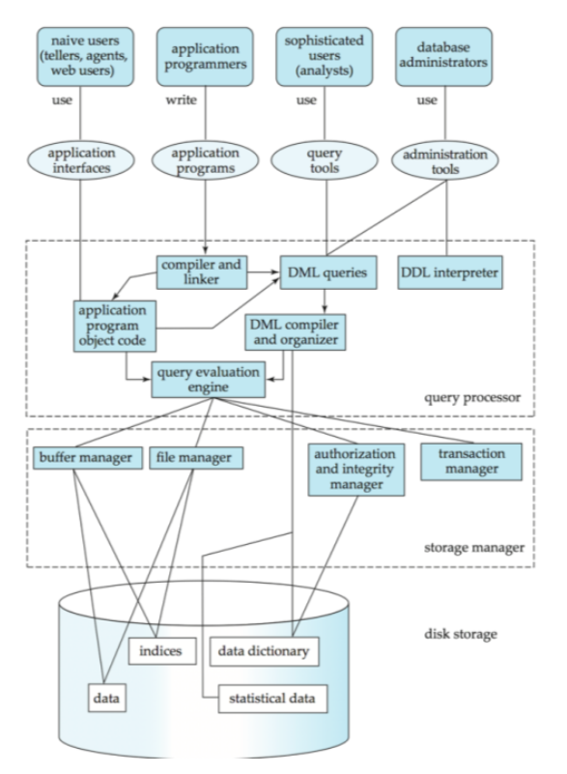

Relational databases:

* Collection of relations/tables
* Each relation consists of sets of tuples/records, each containing same attributes in same order
* each tuple/record forms a row of a table
* each attribute of a record forms a column in a table
  + each attribute has a unique name and particular datatype
* tables/relations can be related via some attribute

**superkey**: set of one or more attributes that uniquely identifies a tuple and distinguishes it from all other tuples

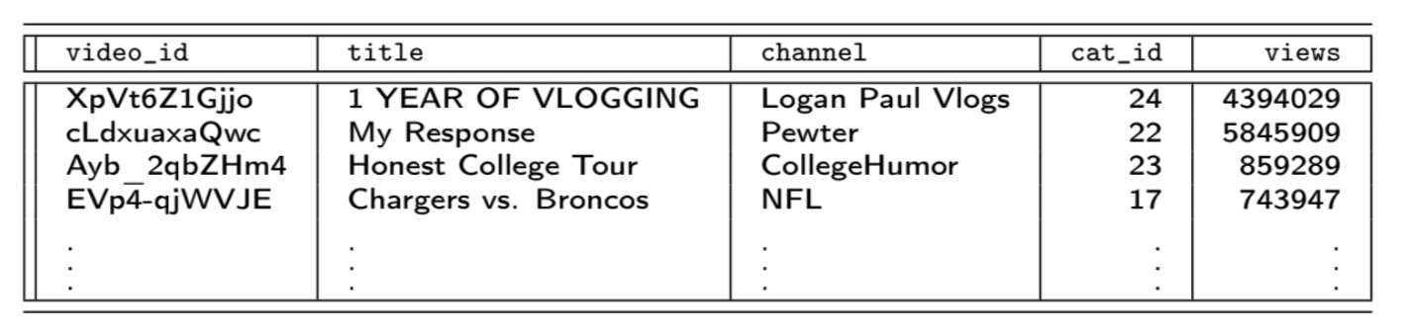

What are the superkeys? It depends:

* Instance: For the instance of the four shown rows, all 5 attributes are superkeys
* Context: For the entire table, video-id, and all subsets of R (relation) containing video_id, are possible superkeys

To find superkeys:

* Compute all subsets of attributes
* Eliminate any subsets that fail the superkey definition definition

More about superkeys:

* In every relation R, there exists at least one superkey
* The most basic superkey is the trivial superkey, which is the set of all attributes of R
* In every relation R, there exists at most 2^n-1 superkeys
* Empty set cannot be superkey
* If k is a superkey of R, and s is another attribute, then k U s is a superkey

Candidate key

* A **minimal superkey/candidate key** is a superkey such that no subset of its attributes from a superkey. There may only be one NULL value in a candidate key
* A **primary key** is a single candidate key chosen by the database designer to enforce uniqueness
  + must be unique, must be NOT NULL
  + to choose a primary key consider:
    1. use case
    2. size
  + composite primary keys may not be minimal

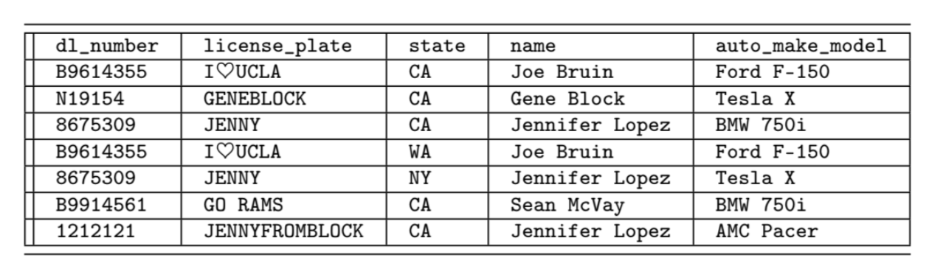

Candidate keys: dl_number U state, license_plate U state

Brute force algorithm for finding keys

1. Find all superkeys
2. Of the keys remaining, look at the set of attributes in them
   1. look at the att
3. If there is more than one key remaining, pick one of them tobe the primary key based on the use case.

**Foreign key**: an attribute, or set of attributes that can be used to link together related tuples of two relations in some way. A foreign key reference the primary key of another relation

* often used to impose **referential integrity constraints**
  + protect data in one relation from becoming orphaned or inconsistent due to changes made to data in another relation
* cascade: delete anything that relies on this particular object
* setting foreign key to NULL allows you to bypass constraints
* foreign keys should not be used for joins

### Schema diagrams

* Box for each relation
* Relation name on top
* Primary key is first attribute(s) listed, should be underlined
* For foreign keys, point from referring relation to referred relation (from foreign key to corresponding primary key)
* 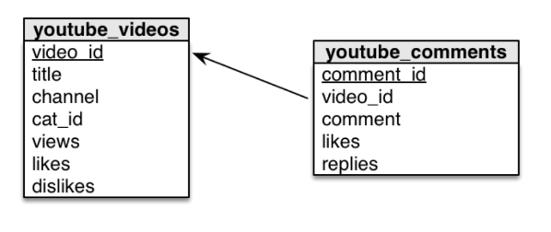
* can be described as:
  + youtube_videos(video_id, title, channel, cat_id, views, likes dislikes)
  + youtube_comment(comment_id, video_id, comment, likes, replies)
  + **no way to represent foreign keys in this format**

### Relational Algebra

* Databases come in many shapes and forms, but all essentially support same set of basic operations (CRUD)
* **relational algebra** is a semantic system for modeling operations on relational data. It provides a theoretical foundation for the relational model as well as query languages such as SQL
* operations we use in the relational model:
  + filtering tuples
  + extracting subsets of attributes from tuples
  + forming all pairs of tuples between two relations
  + merging tuples together based on some attribute
  + performing standard set theory operations on tuples
  + aggregating groups of tuples
  + 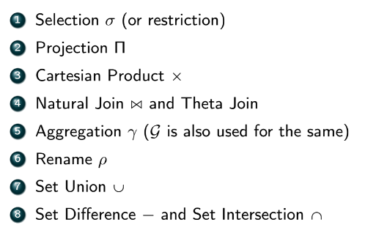
* **selection**
  + retrieves a subset of tuples from a single relation that satisfies a particular constraint and returns a new relation which is a subset of the original
  + 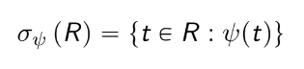
  + : filter expression
* 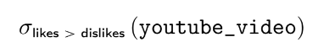: all video tuples where # likes > # dislikes
* 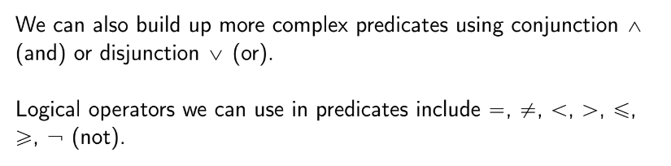
* example:

SELECT * //*get all attributes*

FROM youtube_video

WHERE likes > dislikes //filter expression

AND views > 1000000 //filter expression

AND cat_id = 24 //filter expression

relational algebra: σ l > d ^ views > 1000000 ^ cat_id = 24 (youtube_video)

* : return all columns of a particular table

σ != SQL SELECT. It is instead analogous to **WHERE** clause (or **SELECT * WHERE**)

* **projection**
  + simply extracts attributes from a set of tuples, removes duplicate tuples
  + 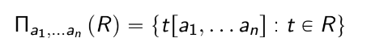
  + projection is typically the last operation done on a relation
  + can be *generalized* to create new attributes (constructs read-only (not part of schema) ephemeral attributes)
  + 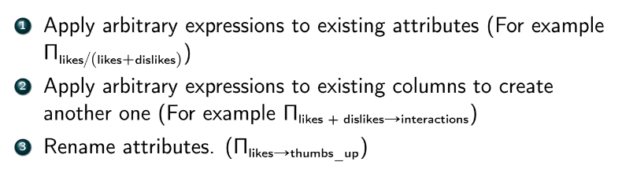
  + 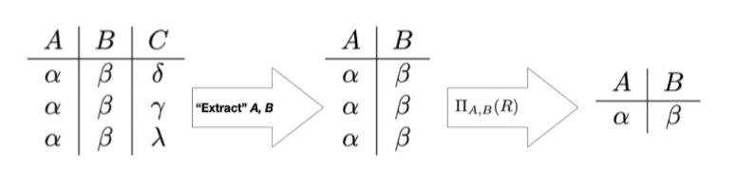
* Π: **SELECT DISTINCT (AS)**
* e.g. write a query to extract the title and channel for all videos that have more than 1 million views and more likes than dislikes
* Πtitle, channel(σl > d ^ views > 1000000(youtube_video))
* *attribute* *tuple filter* *relation*
* 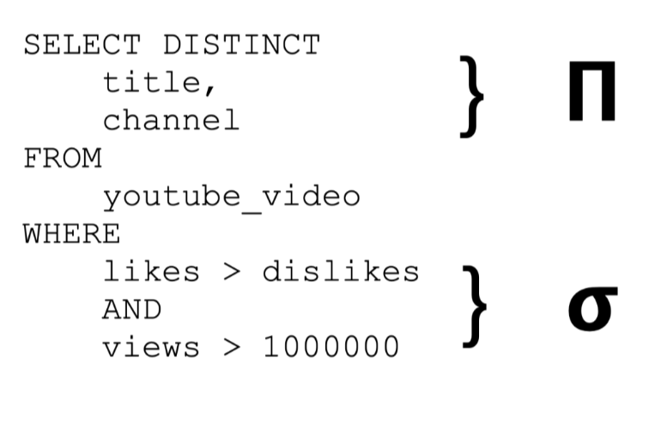
* 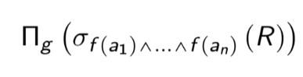 == 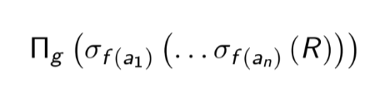
* **cartesian product**
  + combines tuples from two relations, in all possible combinations of tuples
  + 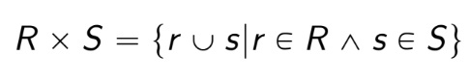
    - all pairs of tuples from R and S concatenated
  + slow to compute, require a lot of RAM, a lot of disk space
  + Cartesian product used to motivate the discussion of a **join**
  + **join**
    - when we want to merge tuples from two different relations R and S based on some contextually related attribute(s) in both relations
    - the result is another relation where each tuple contains data from the tuples of both R and S
    - the attribute(s) used for the join is/are usually referred to as the **join key**
      * join key does not need to be unique
    - good database design relies on separation of concerns to reduce redundancy
      * normalization is used to do this
    - joined relations are denormalized. We do not want to store data in this format
    - **natural join** ⋈
      * RDBMS automatically picks attribute(s) k to join on – the attribute names common to both relations
      * the most simple natural join is defined using Cartesian product
        + 
      * edge case:
        + if R and S have no common attributes, then:

R ⋈ S = R x S

* + - * + if R and S have common attributes but no matches on those attributes, then:

R ⋈ S = { }

* + - **equijoin**: when tuples are combined using equality of values in common attributes (natural join is an equijoin and inner join, except when it is cartesian product/cross join (no common attributes))
    - **theta join:** θ is a constraint that specifies how tuples from both relations will be joined
      * 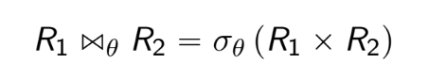
      * e.g. R ⋈R.A=S.A S
      * very powerful compared to natural join
      * if θ consists entirely of equality constraints, it is an equijoin, if not, it is a non-equijoin
    - every join is either a natural join or a theta join
    - every join is either an inner join or an outer join
    - **inner join**
      * merges two tuples together if and only if the join condition is satisfied. The merged tuple is then part of the join result
      * L ⋈L.A=R.A R
    - **outer join**
      * merges two tuples together even if the join condition is not satisfied, but in a specific manner
      * **left outer join**
        + we keep the tuple from L. When we look at a tuple from R and the join condition matches, we merge the tuples together just like with the inner join

for tuples in L with no corresponding tuples in R, we fill in attributes of R with NULL

* + - * + L ⟕L.A=R.A R
      * **right outer join**
      * **full outer join**
* **aggregation**
  + apply an aggregation function to groups of tuples in a relation to summarize them.
    - common aggregation functions:
      * 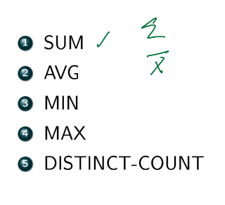
  + major γAVG(gpa)(ugrad_students): average GPA by major
  + global aggregate: γAVG(gpa)(ugrad_students): average GPA for all records
  + γAVG(gpa), MIN(sleep)(ugrad_students): average GPA and minimize sleep for all records
* **rename**
  + ρS(R) renames relation/expression R to S
  + ρa/b(R) renames attribute b in relation R to a
  + R x R is invalid, so we can do ρL(R) x R
* **Set Theory:**
  + when performing an operation on two sets in relational algebra, both sets must be compatible (same # of attributes, same attribute names, same domain/type for each attribute)
  + U: **union**
    - all records that are in R, S, and both R and S
  + – : **set difference**
    - R – S: retrieves tuples in R but not in S
  + ∩: **set intersection**
    - not a join: joins should join incompatible relations
    - 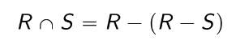
  + 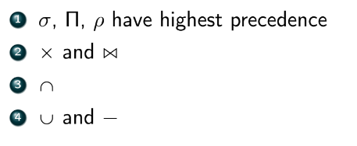
  + 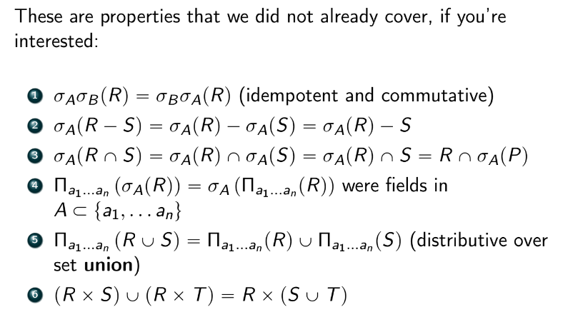

### PostgreSQL Intro

* 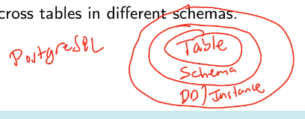
* ANSI SQL compliant
* 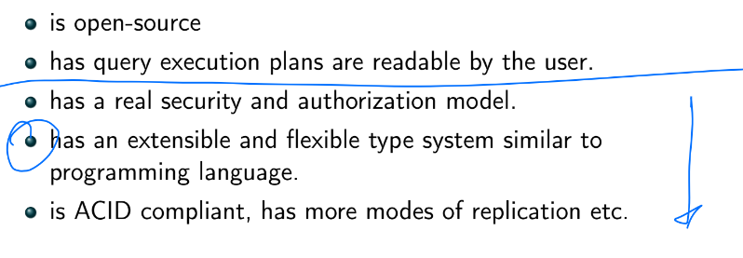
* ANSI SQL types:
  + numeric
    - int(eger)
    - smallint (restricted domain)
    - numerical(p, d): fixed-point # containing p digits, d of which appear after the decimal sign
    - real, double precision: floats and doubles
    - float(n): float with precision of at least n digits
  + string/text
    - char(n): fixed-length character string of length n
    - varchar(n): variable-length character string with a max of n characters
  + binary
  + dates and times
    - 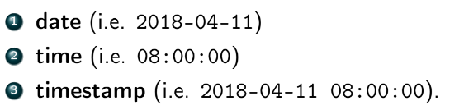
  + null: unspecified or missing value (empty/blank space in PostgreSQL)
* PostgreSQL types
  + 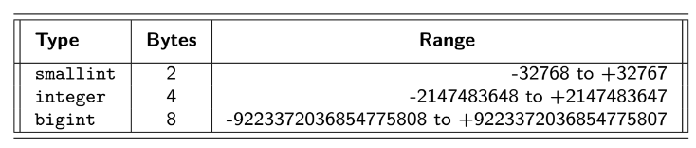
  + exact integer types:
    - smallint: 2 bytes
    - integer: 4 bytes
    - bigint: 8 bytes
  + arbitrary precision fixed-point types:
    - decimal(p, d): same as numeric
      * used for currency, GPA
    - NaN (not a number): must be specified with quotes when referred to explicitly
      * NaN == NaN
      * NaN > everything else except infinity
      * operations on NaN yield NaN
  + floating point types
    - real (1e-37 to 1e37, precision of 6 decimal digits)
    - double precision (1e-307 to 1e308, precision of >= 15 digits)
    - ‘Infinity’, ‘-Infinity’, ‘NaN’
  + char(n), varchar(n), text (1 GB)
    - n = # of characters, *not* # of bytes
  + bytea (hex of escape format)
  + boolean
    - 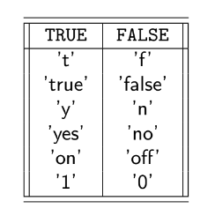
  + bit(n), varying(n): bitstrings
  + timestamp (w/o timezone): 8B
  + timestamptz (w/ timezone): 8B
  + date: 4B
    - yyyy-mm-dd
  + time: 8B
    - hh:mm:ss. …
  + timetz: 12B
  + interval: 16B
  + ENUM: string represented internally as an integer
    - CREATE TYPE mood AS ENUM (‘sad’, ‘neutral’, ‘happy’, ‘sad’)
    - CREATE TABLE person (
      * name varchar(255),
      * current_mood mood
    - );
  + spacial and geometric data types
    - 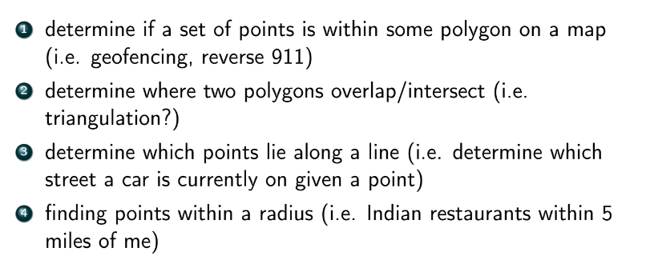
    - 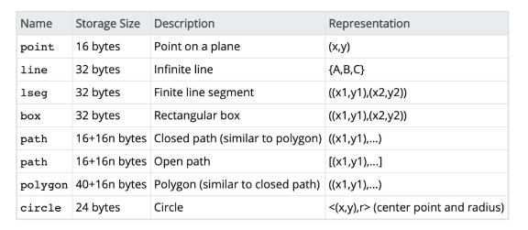
  + JSON
  + XML
  + 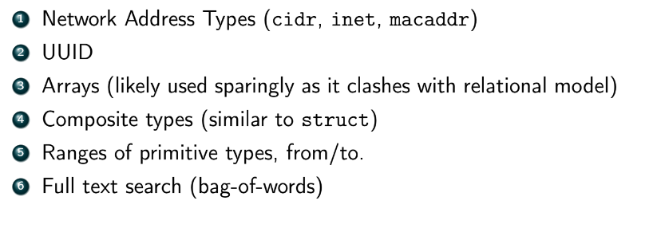

### Data Management

* datatype examples
  + upload date: timestamptz
  + video length/duration: interval
  + description of video: text
  + flag indicating if video is public, private, united: enum
  + video content: bytea
  + user location: point
  + 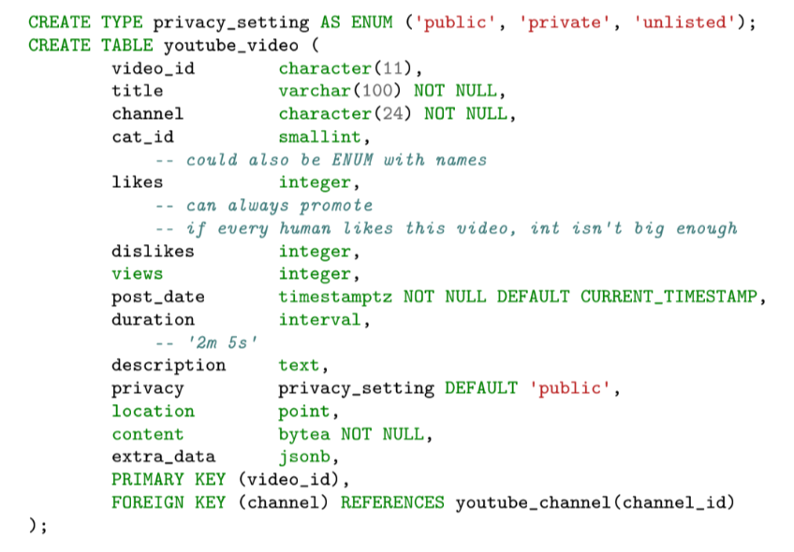
    - FOREIGN KEY (channel) REFERENCES youtube_channel(channel_id) ON DELETE CASCADE *: if channel is deleted, all videos in channel are also deleted

### PostgreSQL

* in PostgreSQL, a schema is a collection of tables/relations that all have similar use case.
  + Creating a relation/table
    - CREATE TABLE IF NOT EXISTS
  + Changing a table’s schema
    - avoid changing schemas if you can
    - promote, don’t demote
    - don’t delete columns, abandon them
    - don’t add columns
    - if you need more columns:
      * have a JSON blob column
      * create second table with join key
    - otherwise:
      * ALTER TABLE
        + add and drop attributes
        + add and drop primary and foreign keys
        + rename relations and attributes
        + add indices and constraints
        + add or drop partitions
        + change data types of columns
        + 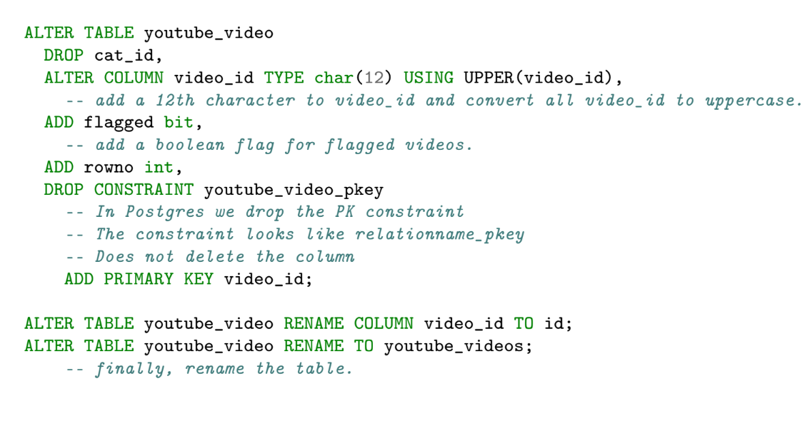
  + Dropping, deleting, truncating
    - DROP TABLE/SCHEMA/DATABASE or DROP TABLE/SCHEMA/DATABASE IF EXISTS
    - TRUNCATE: removes all records from table
    - DELETE FROM … WHERE … : delete particular rows
  + Extracting data from table
    - SELECT
    - 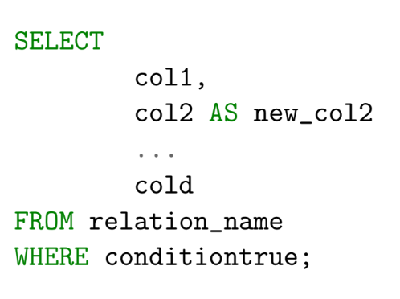
    - Πcols1, col2->new_col2, … cold(σconditiontrue(relationname))
    - :: type cast
    - 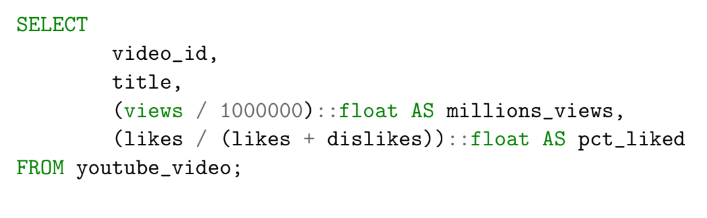
  + WHERE clause
    - WHERE acts on values in columns, one-to-one transformation functions
      * *no aggregation functions*
      * *cannot use AS alias in WHERE clause*
    - =, >, <, >=, <=, !=
    - views “BETWEEN 1 AND 3” is the same as “views <= 3 AND views >= 1”
  + ordering rows
    - ORDER BY [column(s)]
      * ***can*** *use AS alias in ORDER BY clause (only clause you can use aliases)*
      * default: sort in ascending order
        + ORDER BY … DESC: change to descending order
        + 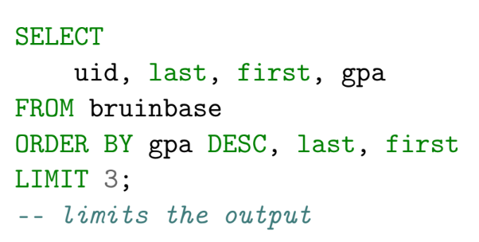
        + NULLS FIRST, NULLS LAST to specify if NULLS come first or last (default–they come first)
      * *use column names*
  + aggregation
    - aggregations over entire relation
    - aggregations by group
    - GROUP BY
      * 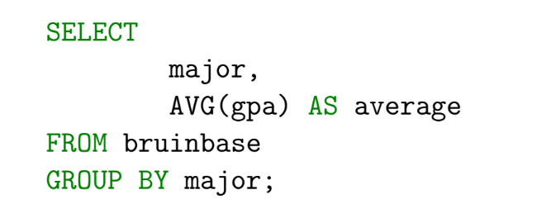
    - 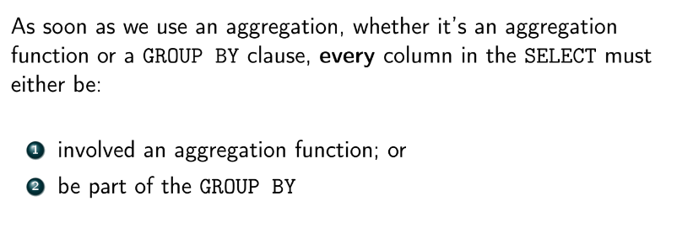
    - filtering on aggregations
      * HAVING
        + 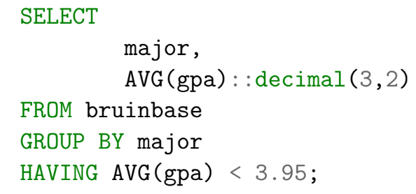
* 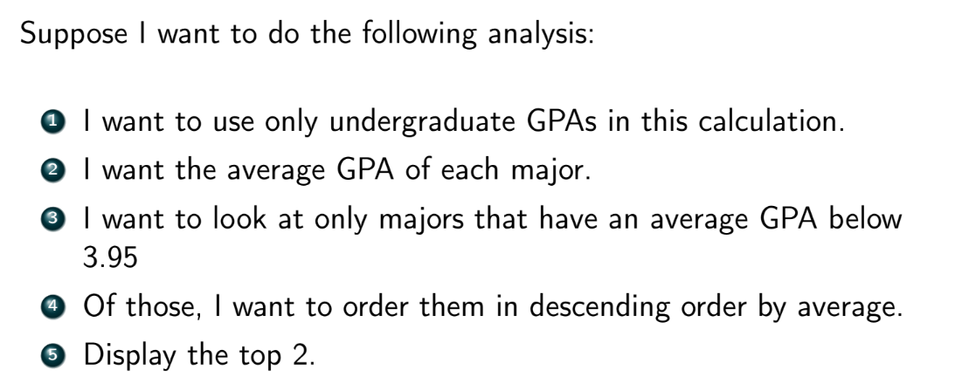
* WHERE, GROUP BY/AVG, HAVING, ORDER BY DESC, LIMIT
* 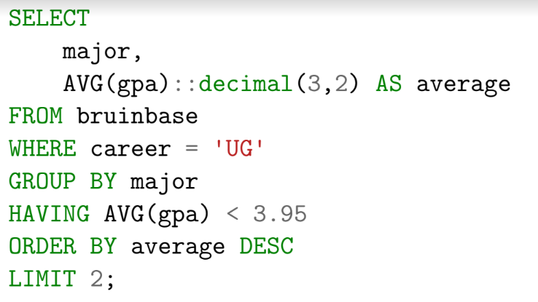
* 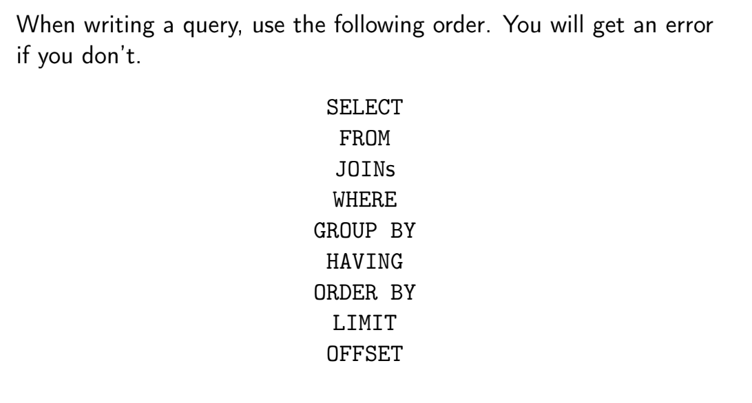
* 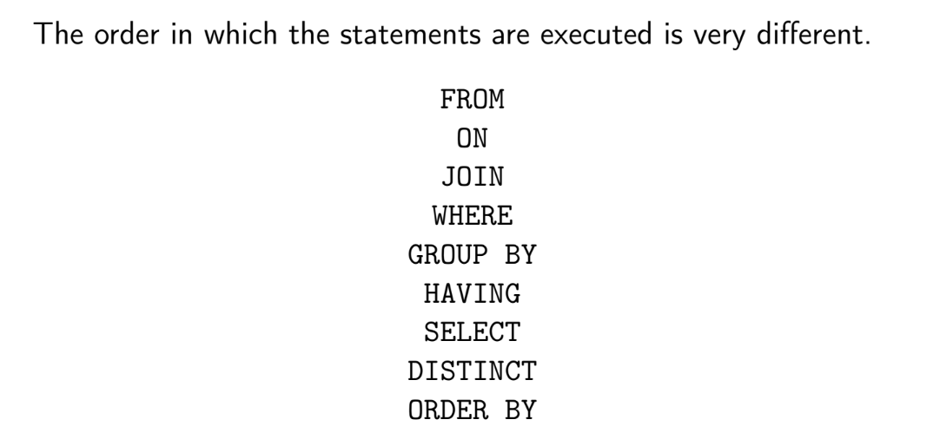

### 

### 

### SQL Joins

* joins are stored in a buffer
* natural join is an SQL anti-pattern (it is dangerously implicit)
  + **inner join:**
  + 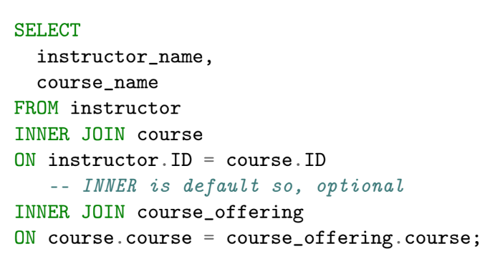
  + or
  + 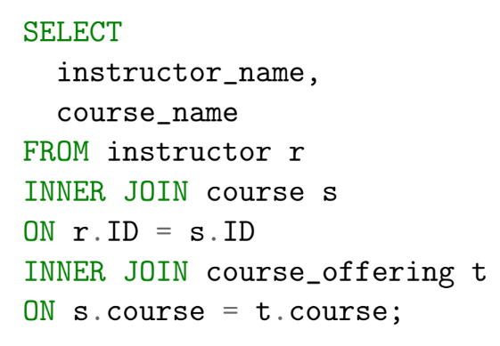
* self joins can be used for network problems, particularly DAGs and trees
  + 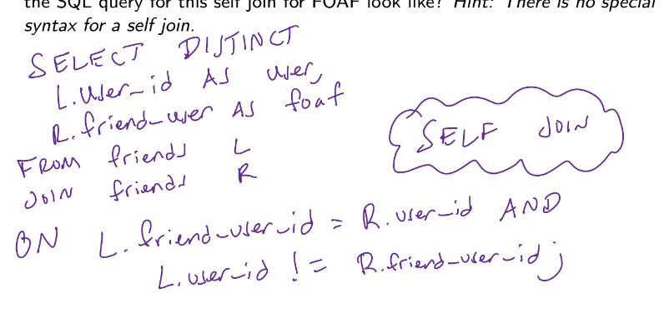
* **outer join**
  + benefit of splitting relation into two tables:
    - only need to append when updating records, instead of searching (e.g. if end_time is nonexistent, we would have to search for the record before updating it
  + in SQL, you need to specify LEFT, RIGHT, or FULL before JOIN
    - JOIN on its own implies inner join
    - OUTER keyword is optional
    - FULL JOIN
      * combines results from LEFT JOIN and RIGHT JOIN
* non-equi self join
  + when we want to compare rows to each other given a particular ordering
  + using it as a sliding window
  + 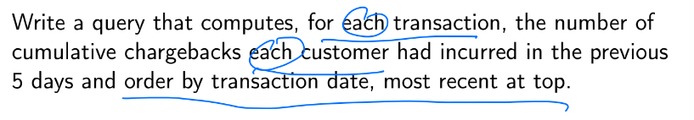
    - 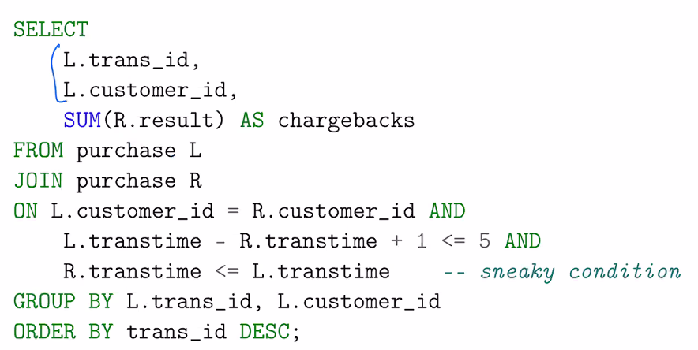
* **cross join** between R and S: cartesian product of R and S

### Nested queries

* innermost subqueries are always executed first
* in PostgreSQL, a subquery can be nestd inside SELECT, INSERT, UPDATE, DELETE
* nested queries are used for:
  + constructing derived tables to chain together processing or aggregation steps in the FROM clause
    - 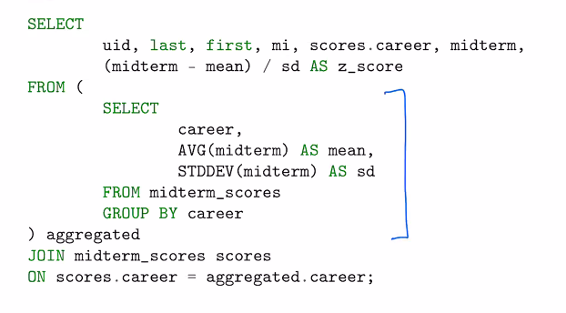
    - derived table must have alias
  + computing constants for use in filters using scalar subqueries (exactly one value)
    - 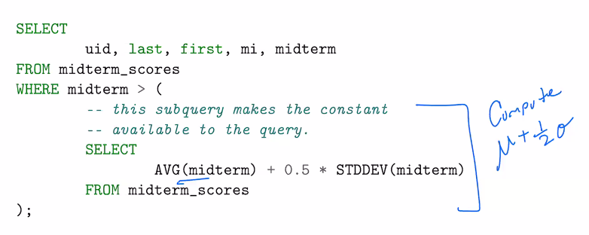
    - 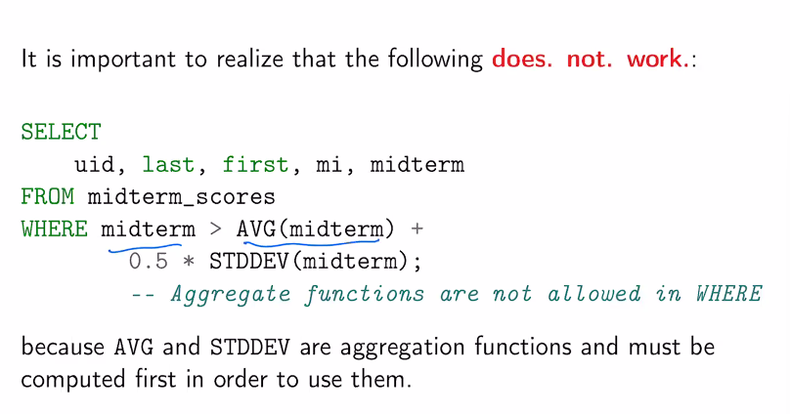
  + semijoin/antijoin
  + a *correlated subquery* is a subquery that uses names/aliases external from the subquery. *These are very inefficient*. The subquery is fully executed for every single row
  + subqueries vs joins:
    - joins can be expensive on larger tables, so we should filter before we join

### Adding new rows

* INSERT INTO relation VALUES (‘val1’, … , ‘valn’) or
* INSERT INTO relation (col1name, …, colnname) VALUES (‘val11’, … ‘val1n’), (‘valn1’, ‘valnn’)

### Modifying rows

* UPDATE relation SET column = new_value WHERE condition

### Data integrity constraints

* CHECK
  + CONSTRAINT constraint_name CHECK (expression)
  + clause can be a boolean expression or subquery
  + can only be used per row
* pros and cons of enforcing constraints in database
  + + enforces data integrity
  + + sets syntax regardless of the app language
  + + don’t need to trust app developer
  + + changes to app don’t break this logic
  + - limited in functionality
  + - less flexible as app changes
  + - more CPU load used on checking constraints
* pros and cons of enforcing constraints in application
  + + constraints can be more complex, closer to the developer. Complex data structures
  + + failures easier to debug
  + - bad user input
  + - need to reimplement if stack changes
  + - not as fast
* best practice is to not delete or update values of primary keys if this is our only source of the data
  + just stop using it
  + RESTRICT (disallow deletion), CASCADE, SET NULL (set value of foreign key to NULL when it is deleted or updated in the referenced table (ON action SET NULL), rarely useful) can be used to update value of primary key
    - by default RDBMS will give an error (RESTRICT by default)
  + ON DELETE/UPDATE SET NULL/RESTRICT/CASCADE
* UNIQUE: forcing a (set of) columns that is not a primary key to be UNIQUE
  + can enforce uniqueness on an individual column, composite of columns (UNIQUE(col1, col2)), or multiple columns independently (UNIQUE col1, UNIQUE col2)

Two philosophies for development with databases

* pros/cons of performing data operations in backend of web app
  + can use procedural language to write logic
  + easier to move data to another database
  + engineers will be more familiar with language for app rather than database
  + don’t need to translate errors from DB to user
  + software/infrastructure changes require rewriting all constraints
  + bad input can break things
* pros/cons of performing data operations in backend of database
  + logic is closer to purpose of database
  + set syntax for constraints, as long as we don’t change databases
  + limited in functionality
  + increased CPU usage
* validating constraints:
  + we need JOINs to validate constraints. On every request to add a record, we have to join tables together
  + alternatively, we can pull raw data for all records, ingest it into app and let the app handle the “join”
    - data will need to be synced frequently
* **rule of thumb**
  + all business logic should be encoded in the app
  + all data integrity mechanisms should be left to the database
  + better solution:
    - use a **cache**: precompute joins for a subset of students, and ingest it into the app which can use its own data structures and algorithms to do processing
      * caching involves storing results of past lookups in system that allows very fast retrieval
      * cache can be refreshed every day/hour
      * could also use a **materialized view**
      * 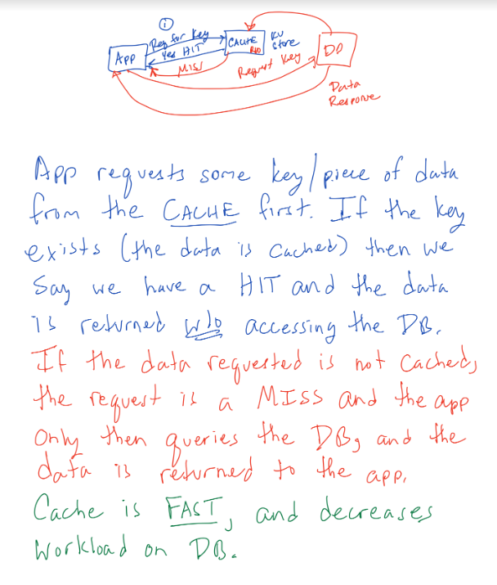
* accessing databases from applications
  + opening a connection to the database using a driver
  + constructing a query
    - various way to construct a SQL query
      * string arithmetic
        + “SELECT * FROM table WHERE column = “ + value + “;”
      * string interpolation
        + “SELCT * FROM mytable WHERE column = {}”.format(variable)
      * prepared query
  + executing the query with a cursor (object that maintains state)
  + iterating over the result set using a cursor
  + closing the ocnnection
* **SQL injection**
  + enter user input such that the input completes an (or multiple) SQL query(ies).
    - 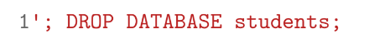
    - 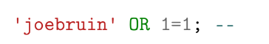
  + **prepared statements** can protect against SQL injection
* cursors and state
  + cursors keep the database connection open, which wastes server resources
  + curursors keep the database in transaction, wasting resources
* logging
  + it’s important to log as much as you can
    - login, logout, auth
    - impressions, interactions, conversions
    - visit path through app or site
    - time spent on pages or screens
    - purchases
    - JS and AJAX actions
* privacy
  + minimize copies of private information in logs
  + use join key everywhere else
  + hash super private data
    - hashes need salt (a random string affixed to data before it is hashed) an pepper (similar to salt, but stored in separate table)
  + have retention policies (don’t keep data longer than needed)
* 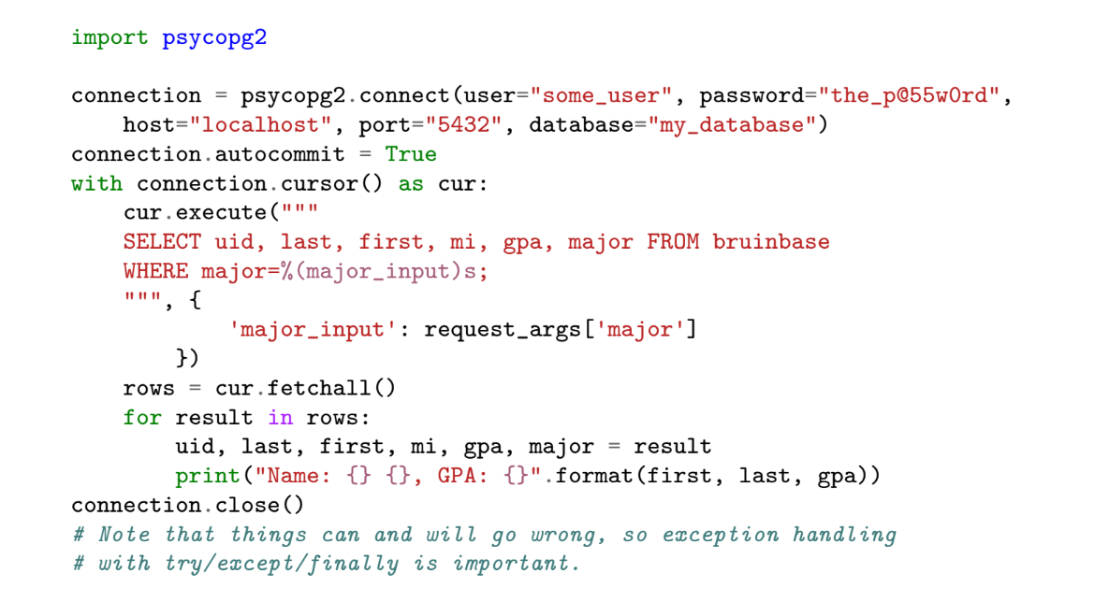

### Normalization

* process of refactoring tables to reduce redundancy in a relation.
* reduces redundancy in tables
* separates concerns in database
* prevents data integrity issues
* prevents delays in creating new records
* **functional dependencies**
  + Heath’s theorem: if a relation R over attribute set U satisfies functional dependency X -> Y, then R can be split into two smaller relations
  + if a table contains redundant data and is nor normalized
  + 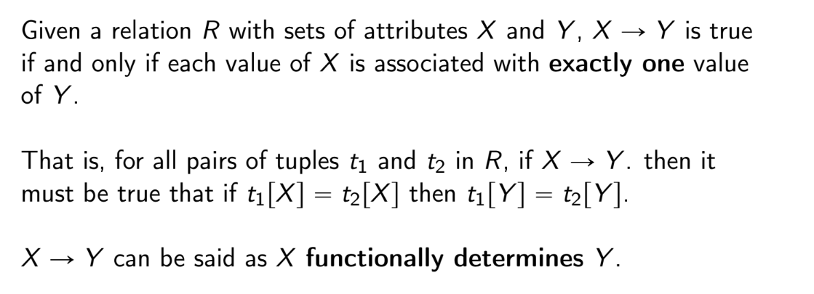
  + when a functional dependency X -> Y exists, it means we can split a table into two, one for the functional dependency X -> Y and one for X and everything else in the relation
  + X -> Y = X functionally determines Y
  + finding functional dependencies
    - depends on context, which will be given
    - e.g.
    - 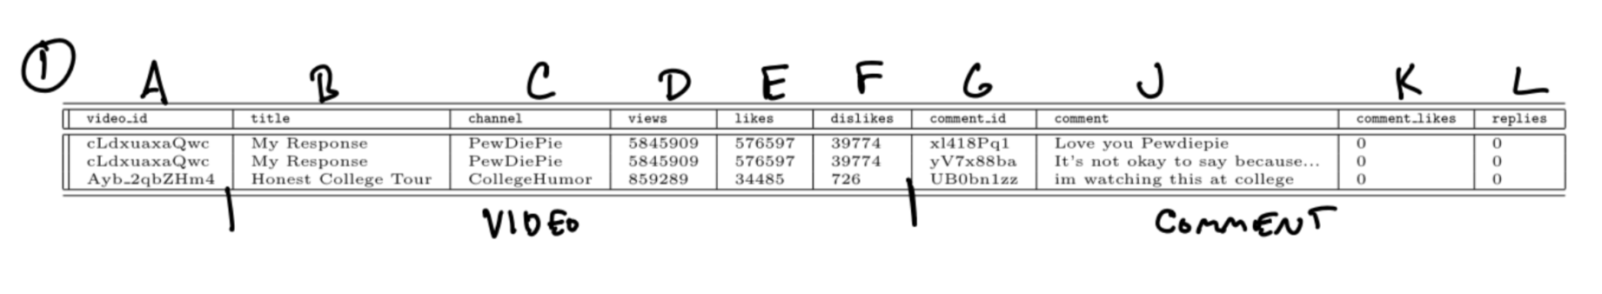
      * A -> BCDEF
      * G -> JKL
      * G -> A
    - to normalize:
      * R1(A, B, C, D, E, F)
      * R2(G, J, K, L)
      * R3(A, G)
  + **properties of functional dependencies (Armstrong’s axioms)**
    - Reflexivity: AB -> A
    - Augmentation: if A -> B, then AC -> BC
    - Transitivity: if A -> B and B -> C, then A -> C
  + **other properties of functional dependencies**
    - Composition: if A -> B and C -> D, then AC -> BD
    - Decomposition: if A -> BC, then A -> B and B -> C
    - Pseudotransitivity: if A -> B and CB -> D, then CA -> D
  + **canonical cover (minimal set)**
    - create singleton RHS (all functional dependencies where right side only has one attribute)
    - remove any extraneous attributes (where LHS has multiple attributes)
      * e.g. if we know A -> C, then AB -> C is extraneous
    - remove duplicate/trivial functional dependencies
    - remove inferred/redundant functional dependencies (we can remove A -> C if we know A -> B and B -> C)
    - apply union rule (A -> B and A -> C means A -> BC)
* denormalized tables
  + issues with INSERT
    - e.g. joining video and comments tables yields denormalized tables; when a new video is created, comments attribute must be specified as null, or video cannot be added to table before comment is posted
  + issues with UPDATE: updating a video requires us to update multiple rows
  + issues with DELETE: deleting a video requires us to delete multiple rows
* why normalization is needed
  + 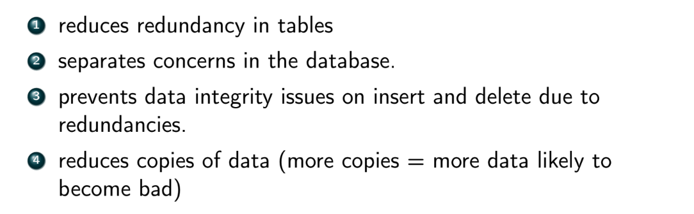
* NoSQL databases typically do not use normalization

### Normal Forms

* property of all normal forms up until 3NF and BCNF: **lossless decomposition**
  + all attributes are preserved in decomposition
  + there exists a common attribute between original and decomposed relation
  + common attribute is an superkey for original and decomposed relation
  + to test for losslessness:
    - 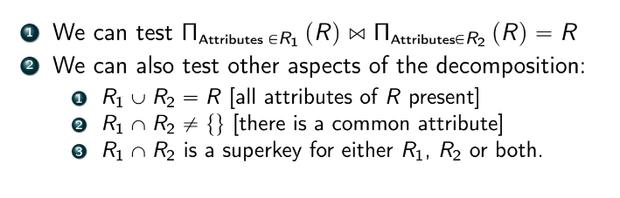
* **dependency preservation**
  + the most obvious way to see if a dependency is preserved is to see if both the left and right side are contained in a single subrelation
    - if not, we can move on to other tests:
      * **functional dependency closure**: using the attributes in the subrelations and axioms on F, can we derive a subrelation where the FD in question holds explicitly?
        + 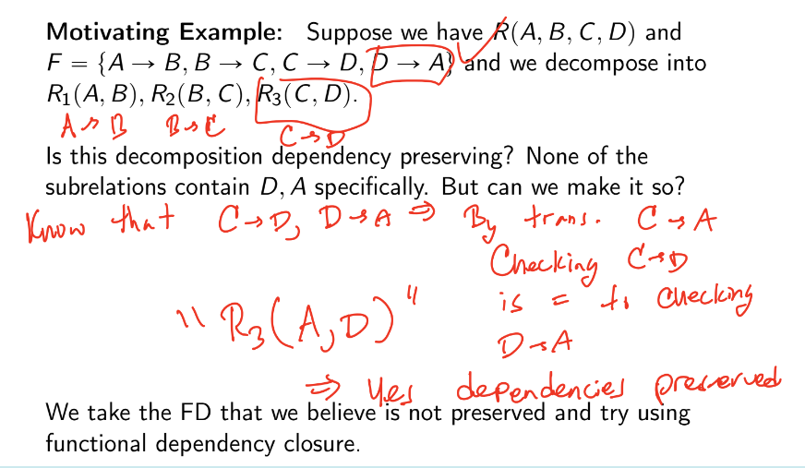
      * **attribute closure**: using all attributes inferred by F, can we rederive all of the attributes in R subject to the decomposition
        + 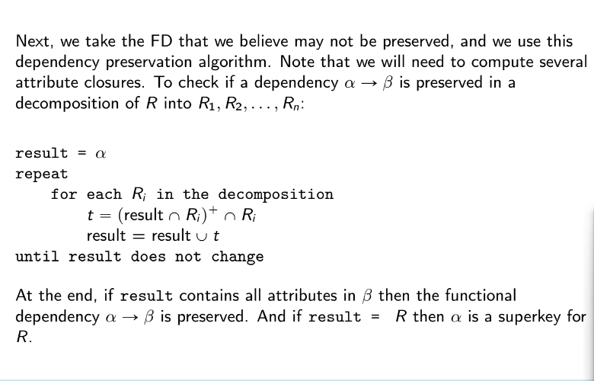
* **First normal form (1NF)**
  + attributes are flat and simple, no nesting, no collections
  + no repeated groups (that impose a non-sense ordering)
  + there is a unique key
    - (all non-key attributes depend on a key)
  + no null values
* **Second normal form (2NF)**
  + any relation that is 1NF and that does not contain any composite keys
  + non-prime (non-key) attributes must depend on the entire key somehow
  + (each attribute depends on the key, the whole key)
  + either of the following has to be true for every attribute:
    - the attribute appears in a candidate key
    - the attribute entirely depends on an entire key (*not partially dependent* on any composite candidate key)
* **Third Normal form (3NF)**
  + any relation that is 2NF and where all attributes that are not part of any candidate key (non-prime attributes) must depend only, directly, on the candidate key(s) and nothing else (transitivity not allowed)
    - there must exist no transitive way to get to a certain attribute from the candidate key
  + (all non-key attributes depend on a key, the whole key, and nothing but the key)
  + at least one of the following must be true for all functional dependencies:
    - A -> B is a trivial FD
    - A is a superkey for R
    - B is part of a candidate key
* **Boyce-Codd Normal Form (BCNF)**
  + for every functional dependency A -> B, at least one of the following holds:
    - A -> B is trivial
    - A is a superkey for R
  + decomposition to BCNF
    - 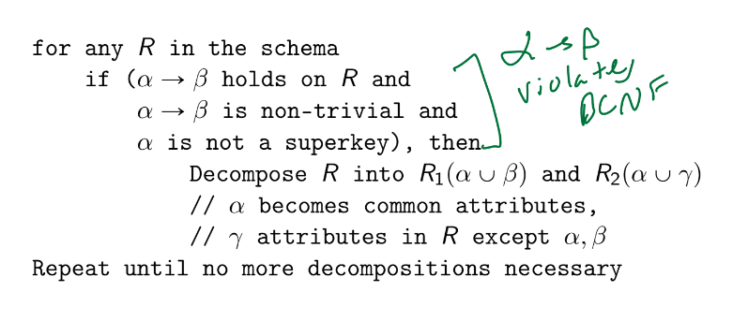
* in read-heavy work, denormalized works better

### Other Data Management Systems

* **OLTP (online transaction processing)**
  + designed for frequent, interactive use
  + random access read/write (transactions)
  + frequently used in production (data read of written by external [unsophisticated] users)
  + simple queries:
    - SELECT FROM
    - JOIN
    - WHERE
    - UPDATE
    - DELETE
    - INSERT
  + abstracts data as a 2D representation called a table
* **OLAP (online analytical processing)**
  + different system, but its abstraction looks similar to OLTP
  + read-only for internal users
    - low-latency reads (SELECT) of aggregated or precomputed data
  + writes can be slow
    - data is loaded into data warehouse during low usage period using ETL (extract, transform, load)
    - 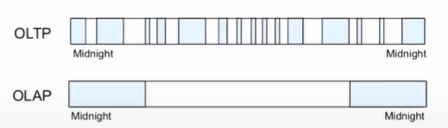
    - either *all of the data* or *only new data since the last update* is transferred
      * costly
        + solution:

run ETL job against replicate

dual writes: on each write to production RDMS, write to replicate as well

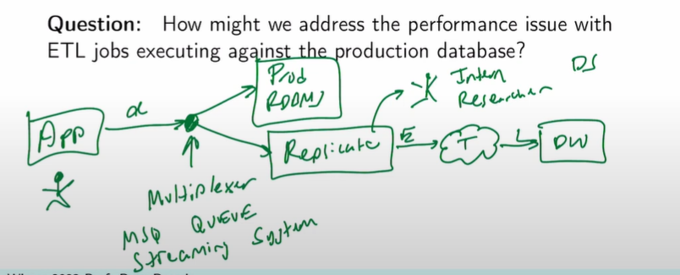

* + - data that is loaded is often aggregated
      * aggregation is costly, so is usually done overnight and cached
    - data that is loaded is often exploded tables (result of joins)
      * join can be prespecified in schema
  + implemented via data warehouses
  + data is conceptualized as a **cube** (rows, columns, depth)
    - users still see/work with table
    - 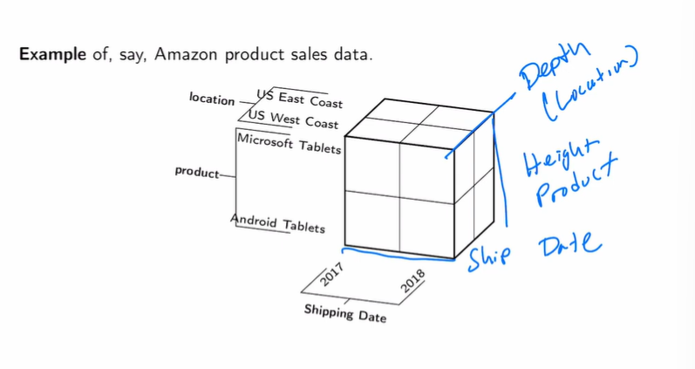
  + used for batch processing
    - reporting
    - dashboarding
  + 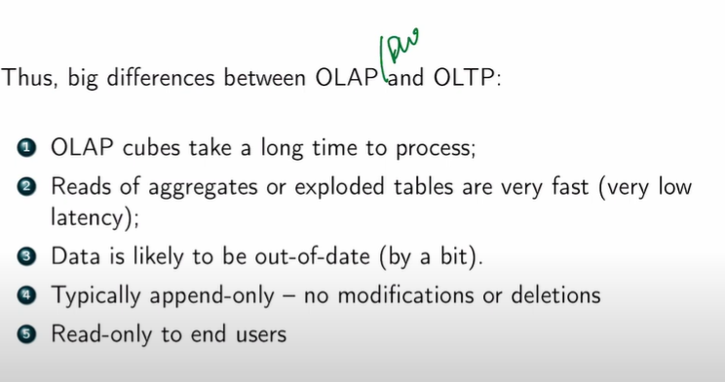
* **OLAP operations**
  + **slice**: selects one predominant dimension from cube and returns a new sub-cube
    - WHERE
  + **dice**: selects multiple values from multiple dimensions and returns new sub-cube
    - WHERE + AND
    - typically not used
  + **rollup**
    - computes aggregates across all levels of a hierarchical attribute (e.g. month, quarter, year, etc.)
    - 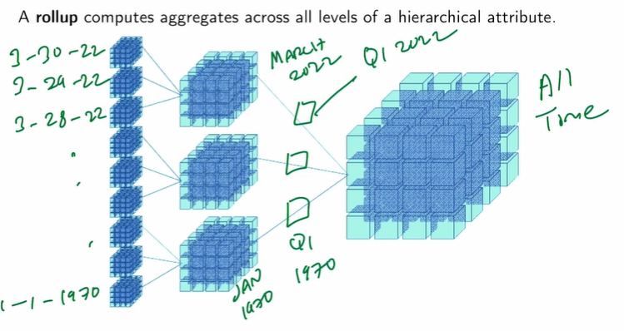
    - 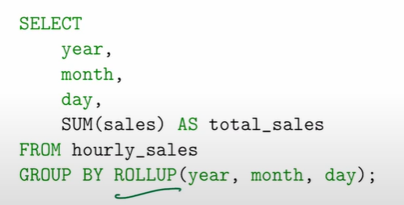
    - 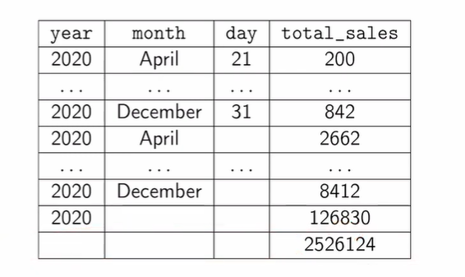
    - CUBE: all subsets
  + **drill down**
    - extracting aggregates at a finer level of granularity
    - **drill up**: the opposite
  + **pivot**
    - converts data from *long* format to *wide* format and vice-versa
    - wide:
      * 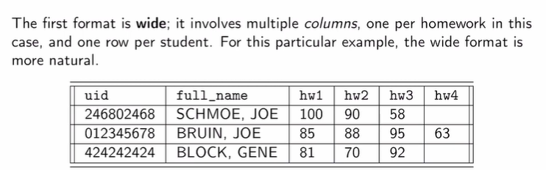
      * - columns are not fixed (may need ALTER TABLE)
      * - NULL values
      * + less contextual redundancy
      * + easier to understand
      * user-efficient
    - long:
      * 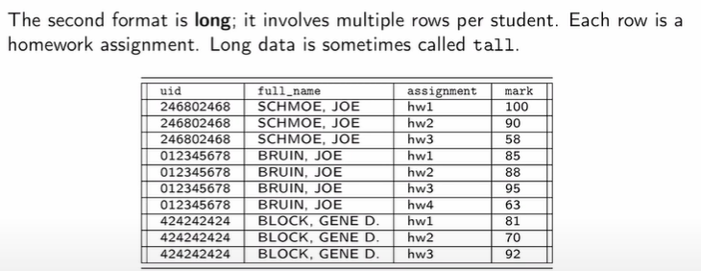
      * can add more HWs without ALTER TABLE
      * no NULL values
      * computer-efficient
    - SELECT CASE
      * switch statement
      * 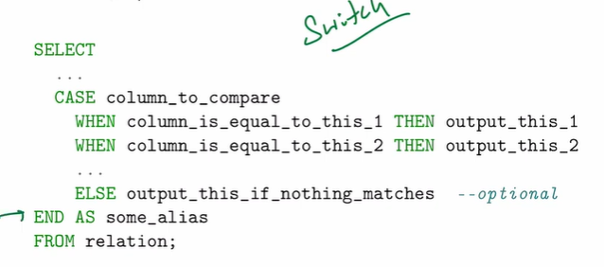
    - 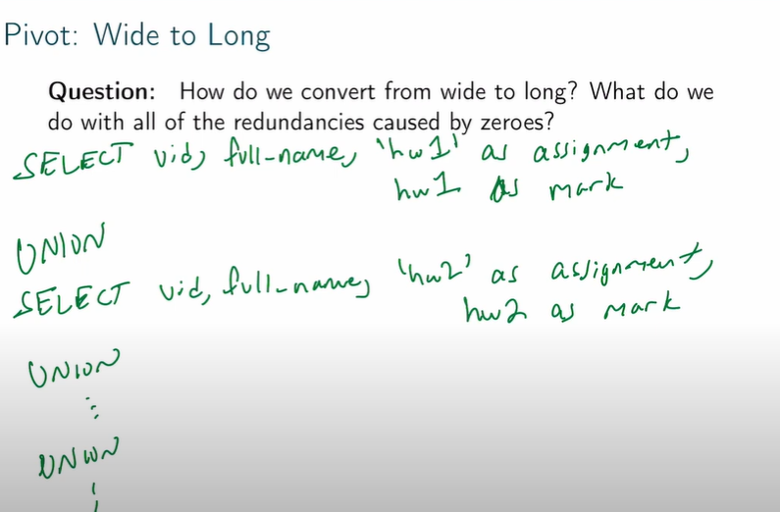
    - 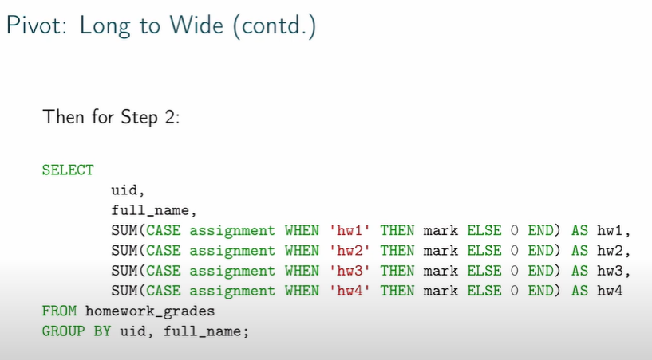
  + **schemas**
    - **fact**: raw data + keys
    - **dimension**: metadata: key -> attribute (describes data)
    - **star schema**
      * 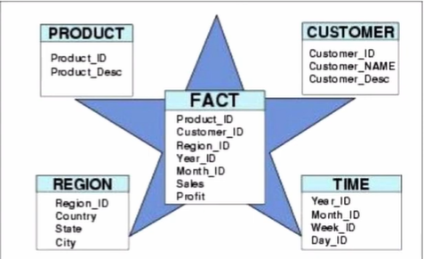
    - **snowflake schema**
      * 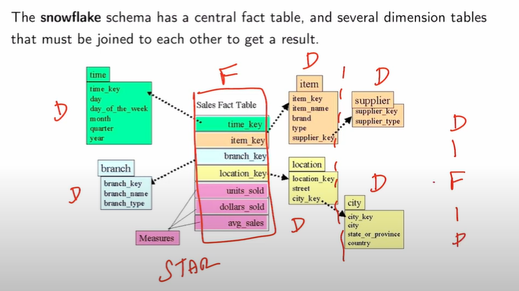
    - **constellation schema**
      * 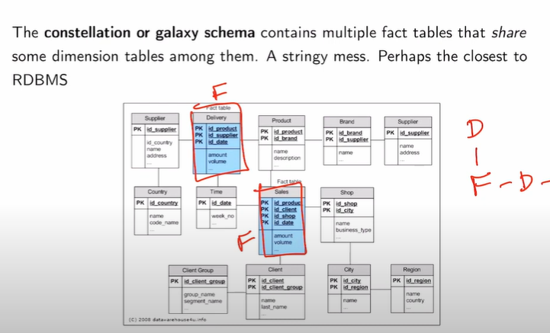
  + 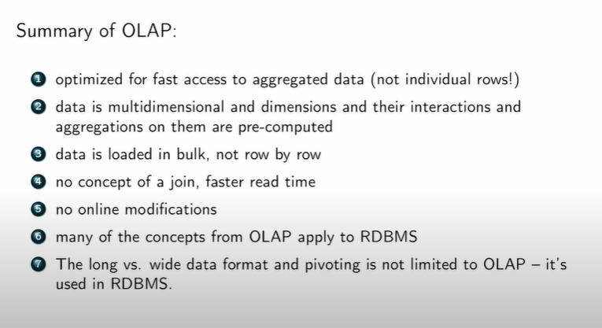
  + typically we have a production and development database
  + 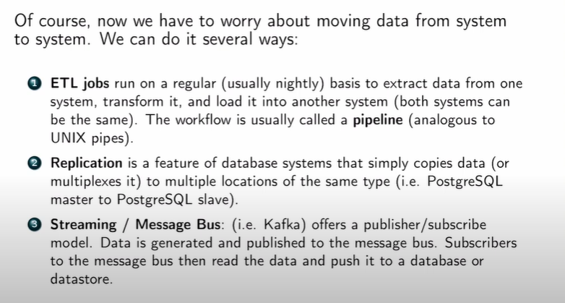
* **data lake**
  + giant repository of raw data
  + different formats in one system
  + HDFS
    - scalable
* 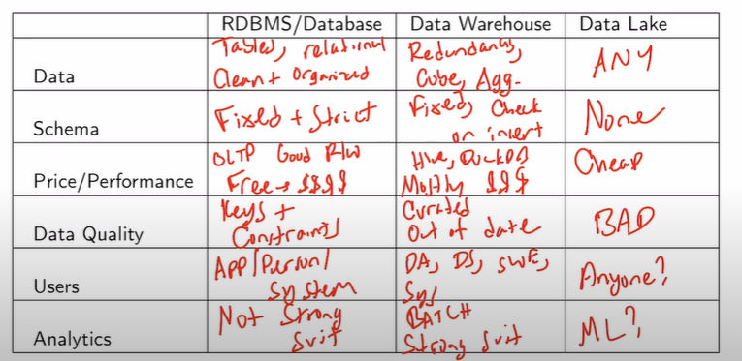
* 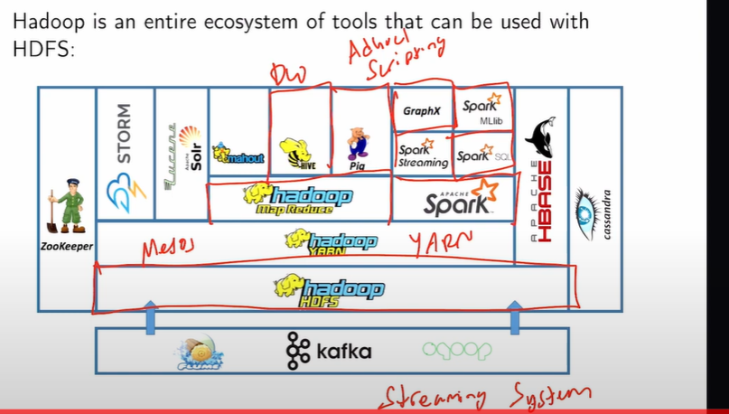
* **replication**: all nodes share almost the same data
  + + load balancing
  + + highly available
  + - if we don’t sync properly, we lose data
  + 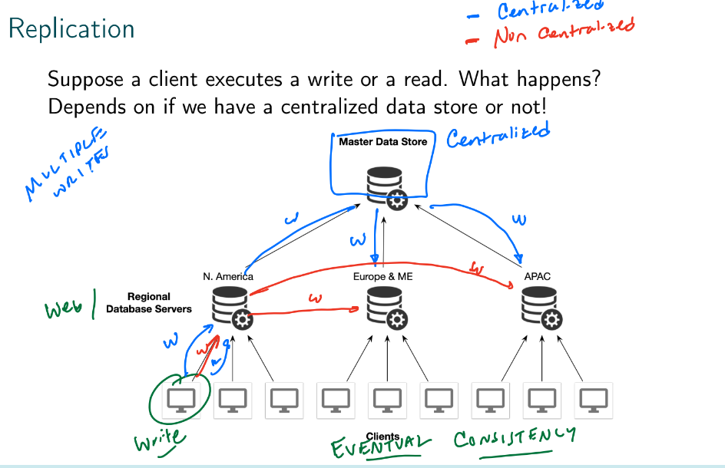
* **sharding**: different nodes contain different data. Shards are usually *geographic*
  + + geographic shards minimize latency
  + can be centralized or decentralized (decentralized = data is only stored in local shard, isn’t ever moved to master data store)
  + 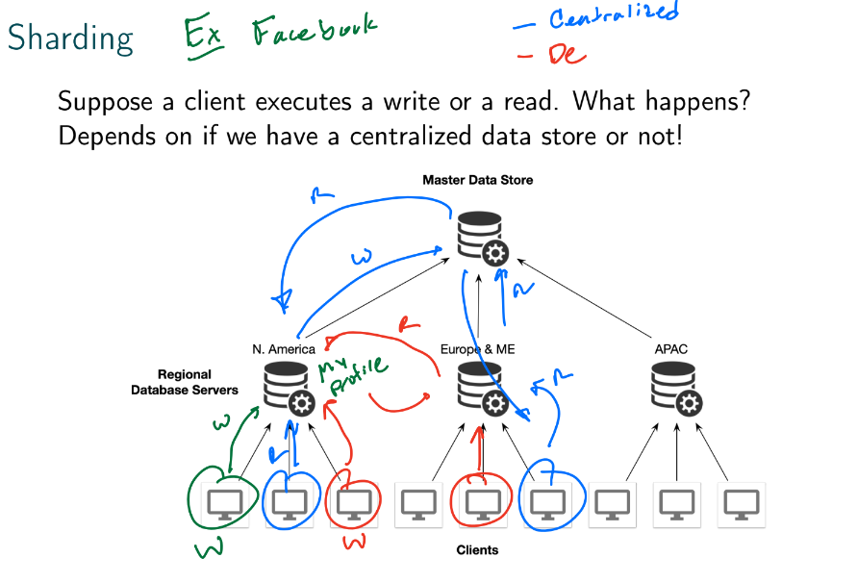
  + centralized system has eventual consistency

### Big Data

* **big data**:
  + “data that is too large to fit in RAM on one machine”
  + purpose is to maximize usage of compute resources (increase bandwidth)
  + **parallelism**
    - doesn’t make data processing faster, but increases throughput allowing us to get a result quicker
    - can make data processing take longer due to overhead

### Map-Reduce

* computational method often used to work with big data
* divide and conquer
* two popular systems:
  + **Hadoop**
    - 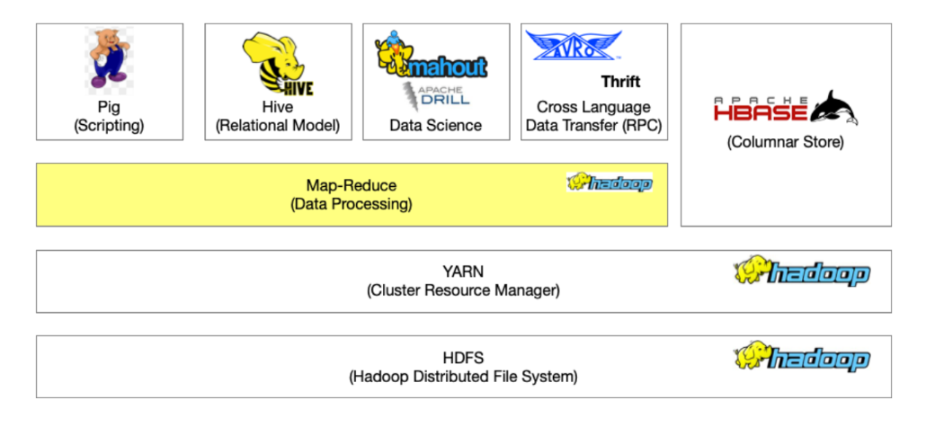
    - **HDFS**
      * 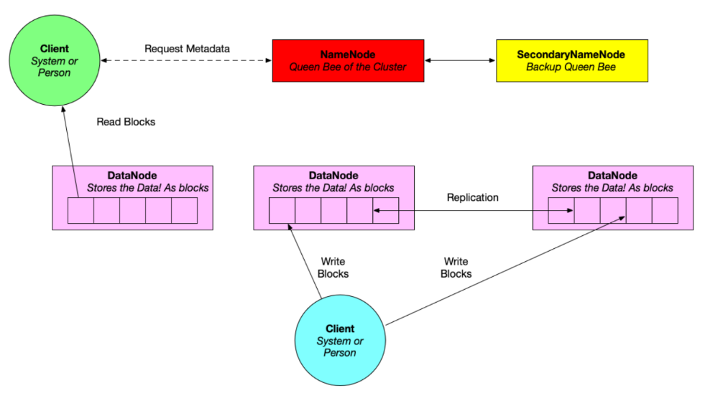
      * NameNode indexes all blocks
  + Spark
  + MapReduce stages
    - input
      * InputFormat
        + how records are laid out in files
        + how to divide groups of records into **splits** (contains many records)

splits are used to defined parallelism, typically contain 1 block of data

too many splits: long time to set up

too few splits: reduces parallelism

* + - MAP
      * outputs key-value pairs (e.g. word -> (word, count))
    - optional combiner
      * (word, 1), (word, 1) -> (word, 2)
    - partition
      * for every key, we compute a hash, use that hash to assign key-value pair to a certain partition
    - shuffle: merge and sort
      * merge: combine pairs with like keys into (key, [list of values])
      * sort: sort by key
    - REDUCE
      * given (key, [list of values]), we execute a reduce function on the list of values for each key (e.g. if we have a list of word counts, we simply sum them up)
      * problems:
        + key skew

certain reducers are going to run for much, much longer than others

solutions:

manually create subkeys

use a custom partitioner: add salt to key, hashes so that keys are uniformly distributed

only need one map+reduce phase

* + - output
  + 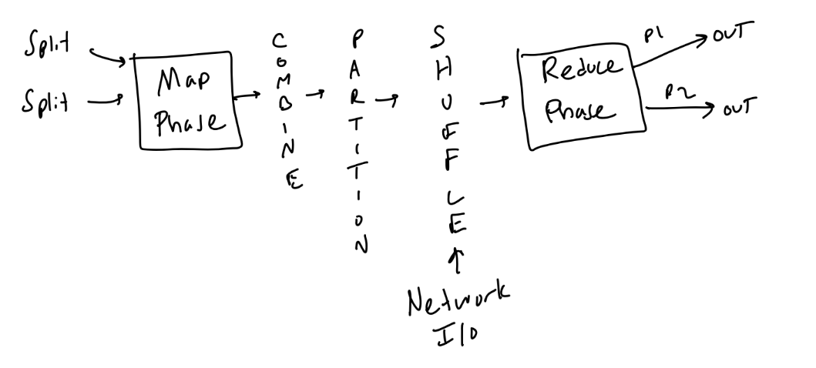
  + example of MapReduce that only contains map phase: parser
  + we don’t partition if we don’t reduce
* 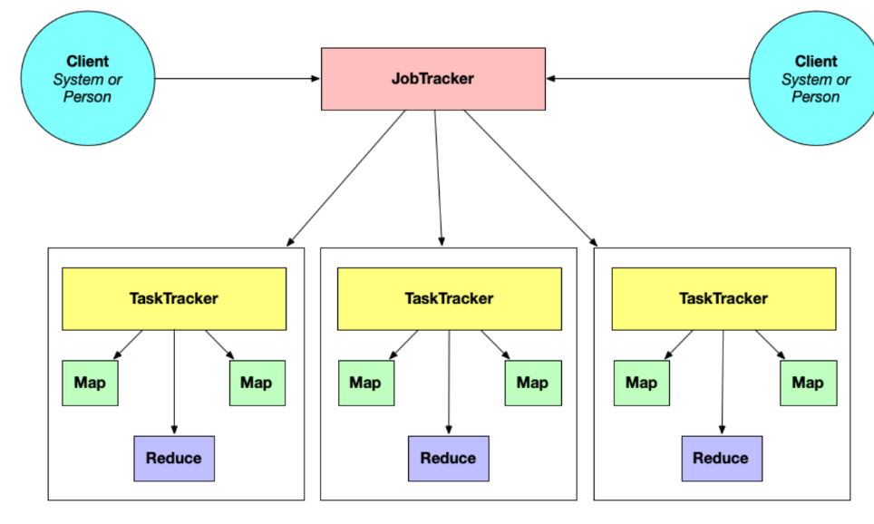
* **SQL in MapReduce**
  + WHERE
    - takes place in MAP phase (prefilter on key-value pairs)
  + aggregation
    - GROUP BY: partition
    - aggregation function: reduce
  + JOIN
    - either
  + subqueries encourage parallelism

### Spark

* we want a **pipeline** consisting of a series of algebraic steps
* Apache Spark
  + uses Resilient Distributed Datasets (RDDs)
  + **RDD**
    - can be of any format
    - resilient: when one node fails, there is a replicate somewhere
    - distributed: parts of the data can be on different nodes
    - immutable (faster)
    - useful when data is unstructured
  + computations are stored in RAM, stays there until the user specifically requests to persist them to disk (collect())
  + lazy evaluation: Spark constructs an execution DAG
    - 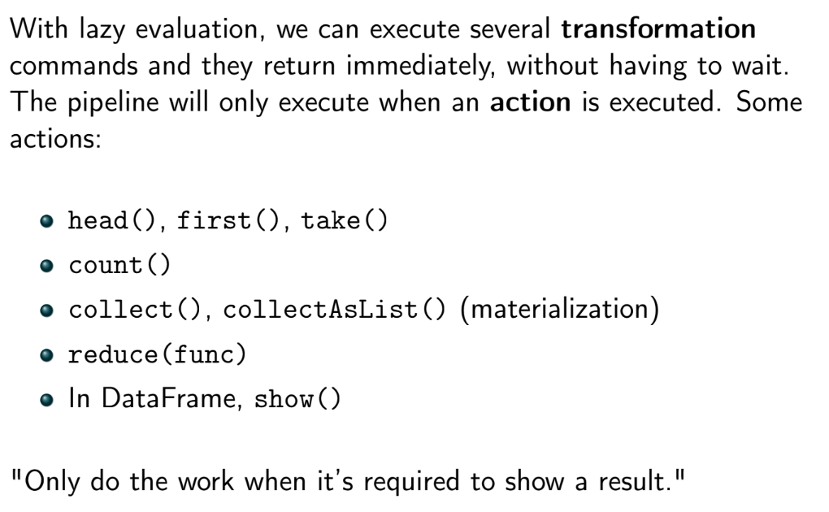
  + can more easily handle iterative problems
  + other advantages:
    - has native APIs for Scala, Java, Python
    - seamless between Pandas and R
    - can use Hadoop infrastructure if necessary
    - can be run in interactive shell
  + disadvantages:
    - disks are slow
* Joins are the biggest source of poor performance in Spark
  + 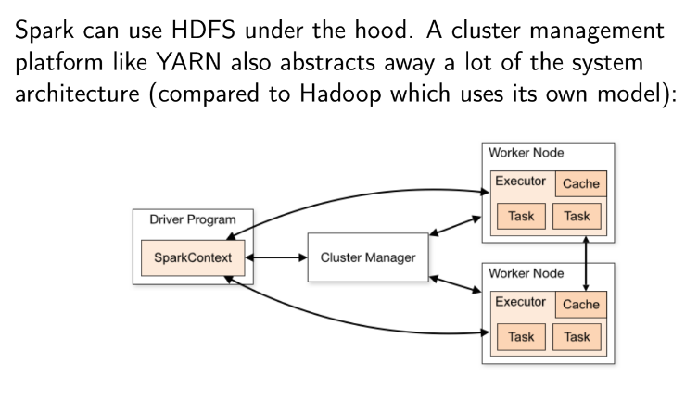

### Streaming systems

* **Lambda architecture**: an architecture that processes massive quantities of data by using both batch and realtime/stream processing
* **data streams** (data arrives as it is produced, dataset is never complete)
  + RDMS, OLAP, MapReduce, and Spark use bounded/complete data, *not* data streams
  + **simple events**
    - e.g. stock price in last 5 seconds, rate of attacks against server, sentiment during presidential debate
    - we have to do something quickly with data without storing it
  + **complex events**: multiple steps
  + involves individual events or messages, each event identified with a time stamp
  + **producer**/publisher/sender: creates an event or message
    - continuously generate events into RDBMS
  + **consumer**/subscriber/recipient: receives and processes message
    - consumer constantly polls RDBMS for new events
    - polling is expensive. Instead, we want the system to “push” notifications to the consumers
  + problems with producer/consumer:
    - producers are hardcoded to consumers
    - producers are also independent
    - if a consumer goes down,producer needs to manually configure a new consumer
    - decentralized
    - network can be lossy
    - producers can transmit data faster than consumers can process it
  + data loss for data streams:
    - when computing an aggregate:
      * data loss is negligible if data is missing at random
      * receiving duplicate messages is negligible if data is duplicated at random
      * receiving data in wrong order isn’t a big deal
    - when replicating to RDMS:
      * data loss is a problem
      * receiving duplicate messages is negligible; can be prevented with primary key
      * receiving data in wrong order isn’t a big deal
  + 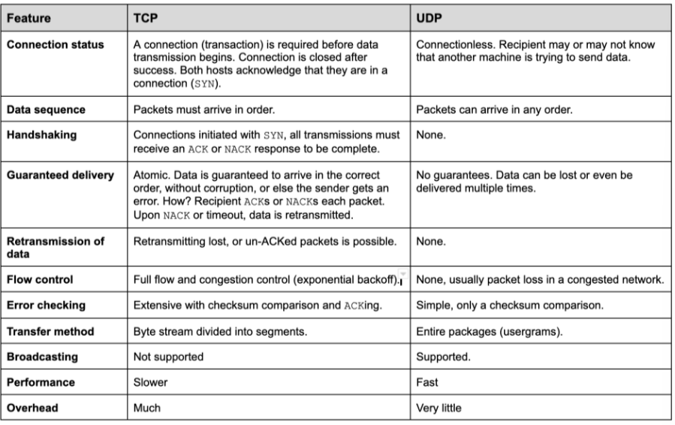
  + **message broker**: sits between producers and consumers
    - producers send messages to broker, consumers read message from the broker
    - centralized
    - handles case where producers and consumers come and go
    - when messages are sent to consumer while it’s down:
      * broker can buffer the message, and then retransmit to another consumer or spin up a new consumer
      * broker then waits for ACK from consumer. When it receives it, it clears message out of buffer
    - handling multiple consumers:
      * **load balancing**: broker chooses one consumer to receive message either arbitrarily or based on shard or partition key
      * **fan-out**: broker delivers message to ALL consumers in particular groups (similar to multiplexing)
    - **TTL**: valid life period of a message
    - commit ack: sent to producer when message has been successfully processed by consumer
    - if consumer or broker bog down/overflow:
      * we can apply flow control or spin up more consumers
      * we can delete the oldest messages in the queue (if recency is important)
      * we can delete messages in the queue at random (computing aggregates)

### Processing streaming data

* we typically process data:
  + over a particular window of time
  + using an update rule if the full window does not fit in the buffer
* computations can be exact or approximate
* with respect to time
  + **tumbling window**: non-overlapping windows of time, consecutive
  + **hopping window** (moving average): fixed length period, but time periods overlap
* with respect to events
  + **sliding window**: constructed with some time period around each event
  + **session window**: defines an entire session from first event of particular type to last event (inefficient, similar to RDBMS)
* straggler events: produced in window w but does not arrived until after w has been closed an processed. What can we do?
  + ignore stragglers
  + later offer a correction
    - requires that aggregate is updatable, easily
* **bloom filter**
  + 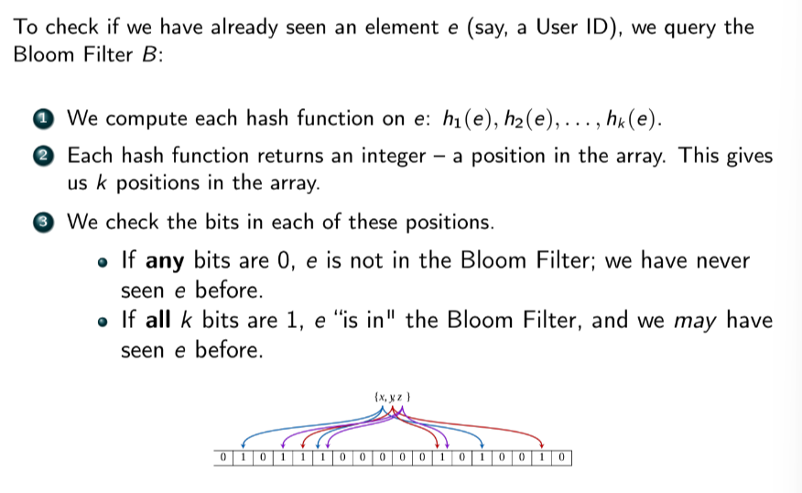
  + 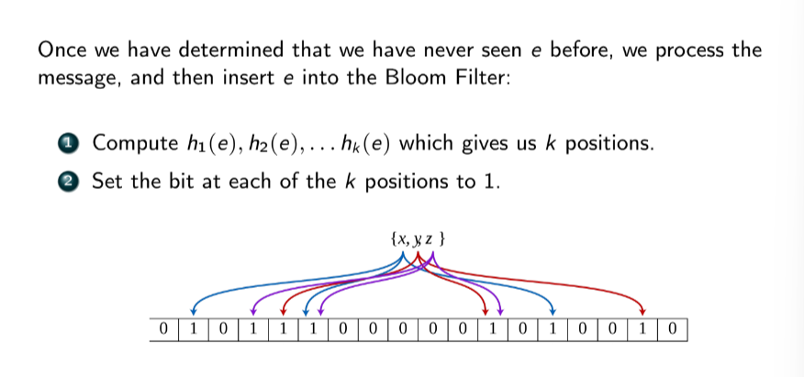
* **HyperLogLog**: similar to bloom filter, but we treat bitstring as a binary number and use run lengths and probability to provide an estimate of the number of distinct objects in a set

### NoSQL

* Two different concepts:
  + a database where DML and DDL is something other than SQL (we prefer “not only SQL” instead of “no SQL”)
  + a database system that doesn’t use the relational model
  + common models:
    - key-value store
    - columnar
    - document store
    - graph
* most NoSQL systems are designed to be distributed. They make use of
  + replication (multiple copies of data distributed throughout system
  + sharding: different partitions of data live on different nodes
* **CAP theorem**
  + 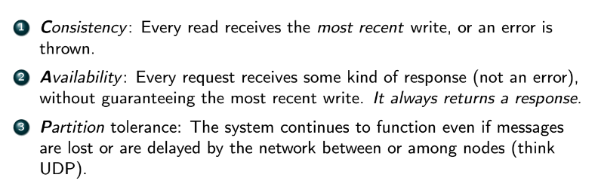
  + *it is impossible for both **C** and **A** to be satisfied *when a network partition or failure occurs in a distributed data system*
  + **P** must always be satisfied in a distributed system
* **Redis**: key-value store, but can be used as data structure store
  + data types:
    - 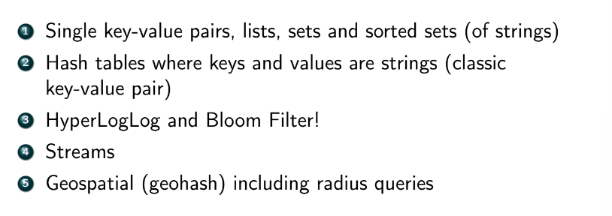
  + persistence achieved through **snapshotting** from RAM to disk or a journal that records operations performed on data in RAM
  + Redis uses:
    - session caching
    - message queues
    - leaderboards
    - fast lookup and indexing
  + CAP is irrelevant to Redis since Redis isn’t distributed
* **Columnar databases**
  + fixed number of columns
  + each row contains different set of those columns (each row can have different numbers of columns)
  + **Cassandra**
    - 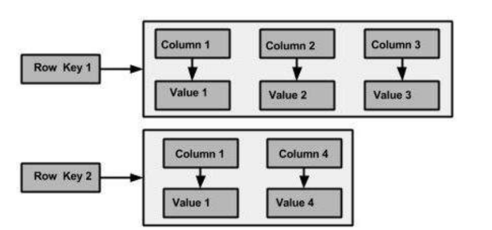
    - cannot use joins
    - designed to be unnormalized for fast lookups (used in data warehouses)
    - no foreign key, but primary keys do exist
    - rows are strictly ordered
    - uses **CQL (Cassandra Query Language)**
    - eventually consistent
    - Cassandra is AP
* **document store**
  + **MongoDB**: multiple databases, within each database there are multiple collections of documents. Documents are schemaless, there is no requirement that documents follow a strict schema
    - each document is in a JSON-like format called BSON
    - records -> collections -> databases
    - use *find* or *findOne* to find data
    - 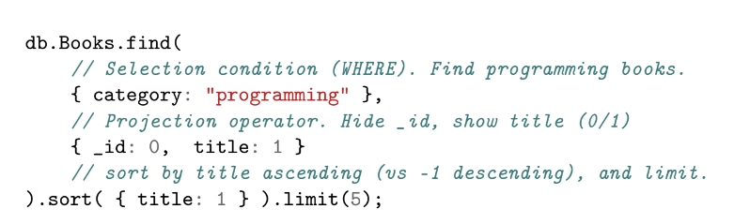
    - 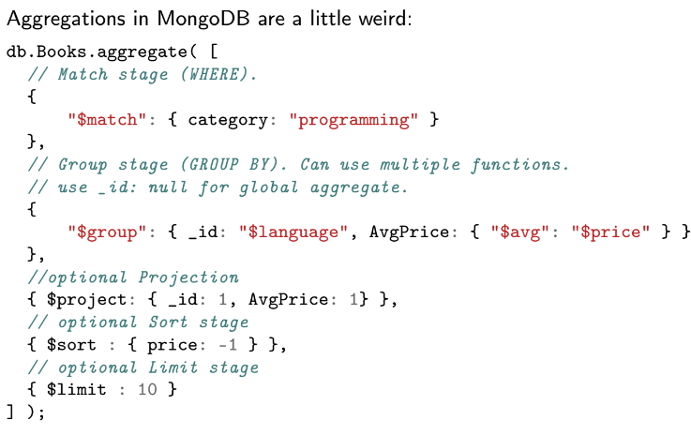
    - 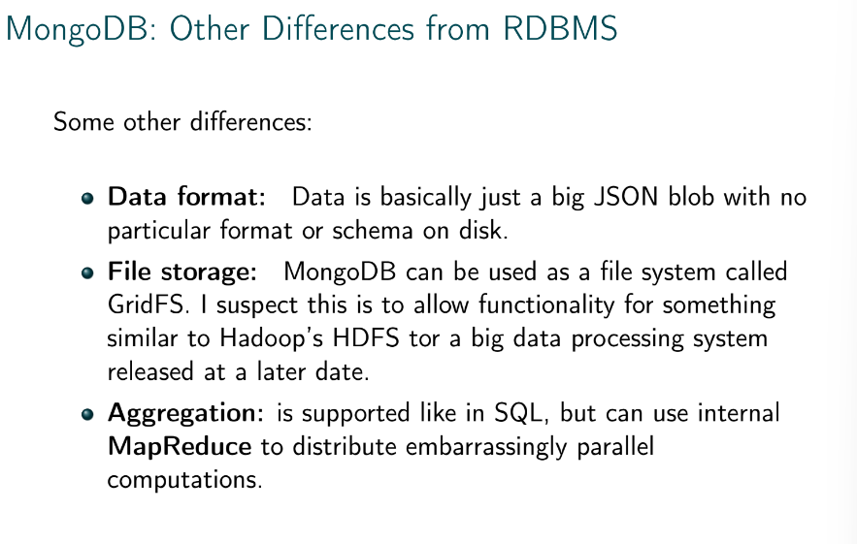
    - ensures strong consistency
    - uses horizontal sharding
    - by default, MongoDB is CP
    - Mongoose is a popular ODM for MongoDB
* **Graph store**
  + data stored as node or edge
  + nodes represent entities/relations
  + edges represent foreign keys/relationships
  + nodes and edges can have properties and labels
  + edges are usually directed but can be traversed in either direction
  + 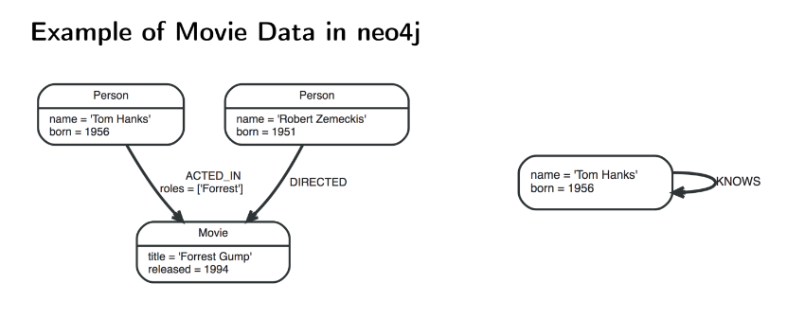
  + **neo4j**
    - uses Cypher with MATCH and WHERE constructs
      * MATCH: specifies a node pattern for pattern matching
      * WHERE: similar to SQL WHERE, but applies to properties of nodes
      * 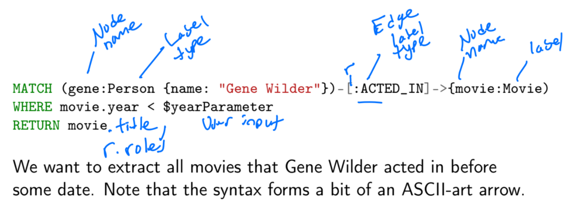
    - supports but does not require schemas
    - traversing the graph is the equivalent of executing a join
    - CAP theorem doesn’t apply to neo4j

### Data storage

* **storage engine/storage manager**: responsible for storing, retrieving, and managing data in memory and on disk
  + also handles swapping data between disk RAM
* we choose how to store data on a system based on
  + speed of access
  + cost per unit of data
  + data reliability
* disk performance
  + access time: time from r/w request to time that data transfer begins
    - seek time + transfer time
  + seek time: time for head to move across platter to a sector
  + rotational latency: on in a track, how long for sector to be under head
  + data transfer rate: time to transfer data in sector from disk to main memory
* data on disk is addressed by a **block number**. Data is transferred between RAM and disk in term of **blocks** (pages)
* SSD’s optimize for random access, HDD’s are optimized for sequential access
* **file organization**
  + 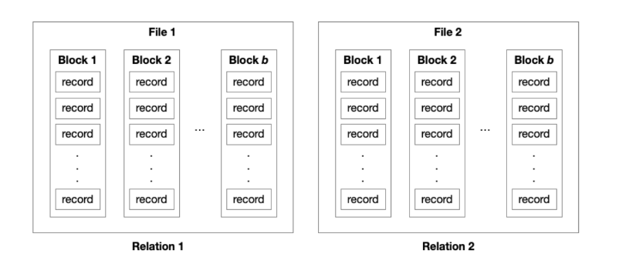
* fixed-length records
  + easy to process, wastes space
  + overflow block:
    - 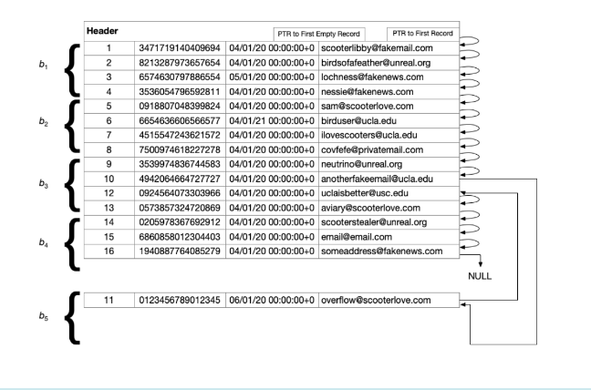
* variable-length records
  + organizing record into a file:
  + 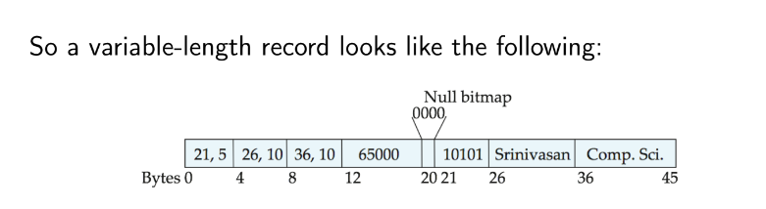
    - table of contents pointing to variable sized attributes, then data for fixed size attributes, then null bitmap, then data for variable sized attributes
  + space efficient, pain to process
  + organizing record into block:
    - 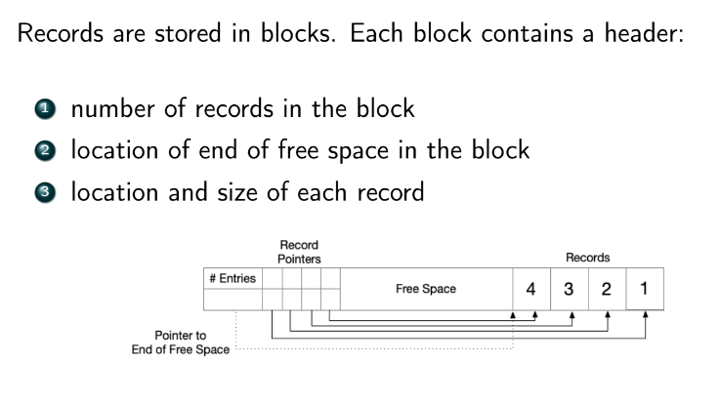
* **Index**
  + given a record key, we can retrieve a **block number** and a **byte offset** within that block
  + **ordered indices**: based on a sorted ordering of the sort-key values (sequential access)
    - **primary (clustering) index**: index entries sorted in the same method/order as the underlying data file
      * + block reads are minimized
      * + can perform range queries
      * - difficult to maintain contiguity on disk
    - **secondary (non-clustering) index**: data file is sorted by a different key/attribute than the index
      * must be dense
      * less efficient than primary indices
      * often used when there is no primary key
      * may need overflow block
  + **hash indices**: based on a uniform distribution of values across a range of buckets (random access)
  + **dense index**: every key that appears in a record also appears in the index
  + **sparse index**: only a subset of the keys that appear in records appear int he index
    - usually only the first key in each block appears
  + can have multiple indexes on a file
  + primary index not required
  + may have 2nd index on foreign, join, or unique key
  + 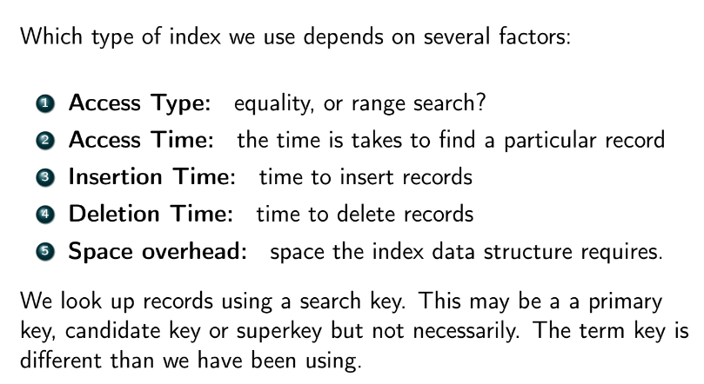
  + **B+ Tree**
    - 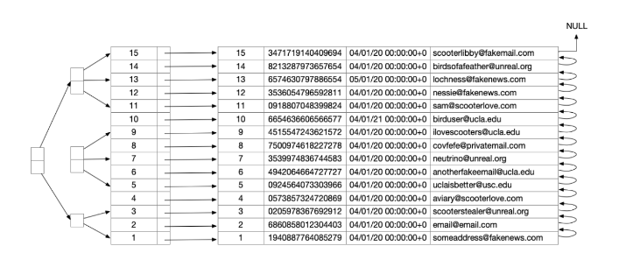
    - uses divide and conquer
    - 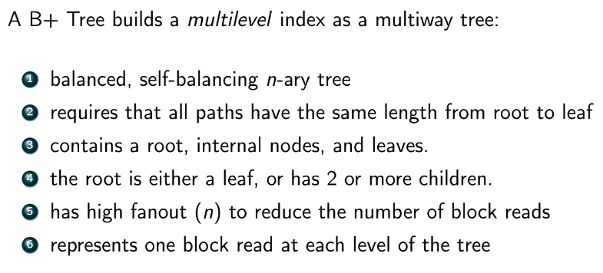
    - Uses:
      * Filesystems use B+ trees to index metadata about files
      * Key/value stores use B+ trees for data access
      * 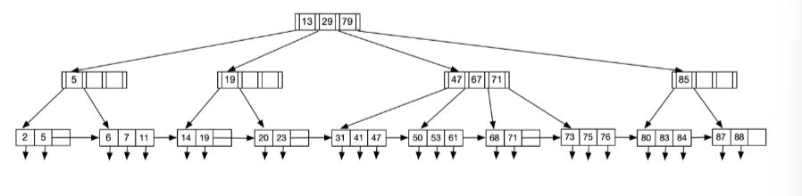
        + bottom layer consists of keys that point to records on disk
    - leaf node contains n pointers and n-1 key-values
      * 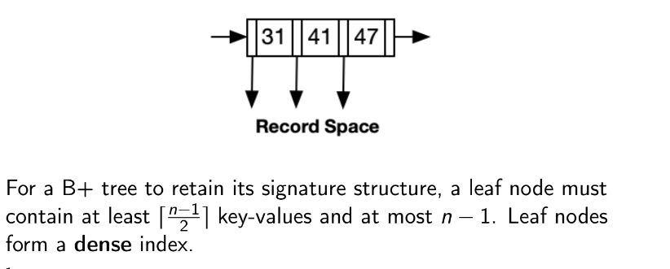
      * 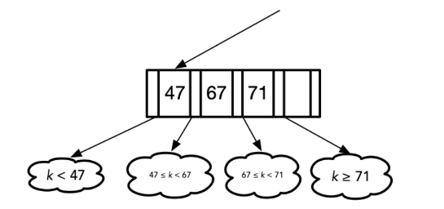
      * non-leaf nodes for a sparse index on leaf nodes, holding up to n pointers and must contain at least ceiling(n/2) pointers
    - slow insertion/deletion/query time, but fast rebuild time
    - given height of tree = h, time to find key is (h+1)(ts+tt)
      * ts = seek time
      * tt = block transfer time
    - range query: find keys between a and b
    - *pointer collection method***:** traverse all leaf nodes in range
    - *record collection method*: go all the way down to record space before traversing all records in range
    - **cons of B+ trees**
      * may have duplicate keys
        + solution: merge non-unique key with PK
      * variable length attributes, like strings, make it difficult to store in a tree
        + solution: use something else
      * bulk-loading arbitrary data into B+ tree is very inefficient
        + solution: load data first and then build tree
  + **Indices in SQL**
    - 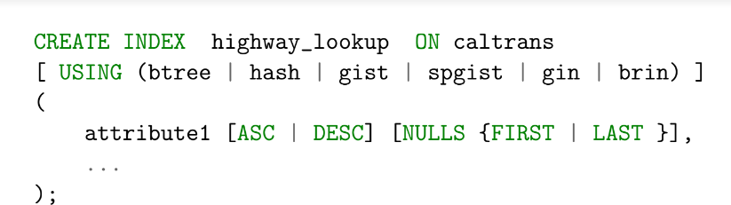
  + **hash indices**
    - good at equality queries, bad at range queries
    - cons:
      * insufficient buckets
      * bucket skew
    - static hashing: assume 1.2x the number of records you’re going to have
    - dynamic hashing
  + **indexing spatial data**
    - k-dimensional tree can be used to represent spatial data
      * 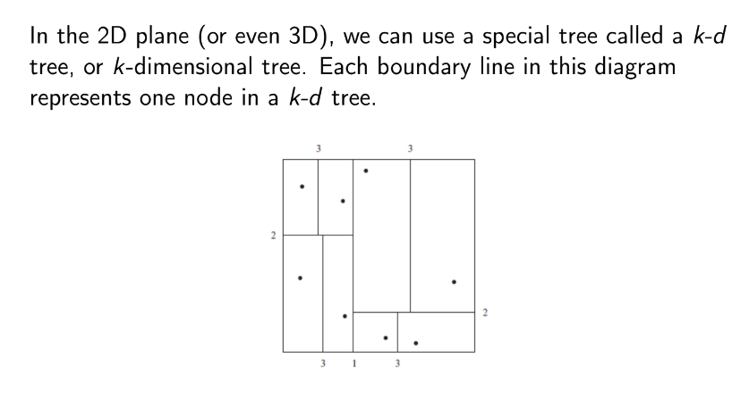
  + temporal data can also be indexed

### Query processing

* results of query processing
  + parsing and translating -> expressions that can be used at physical level of RDBMS
    - similar to parser in a compiler
    - ensuring syntax is correct
    - translates to an internal form that is based on relational algebra
    - e.g.
      * 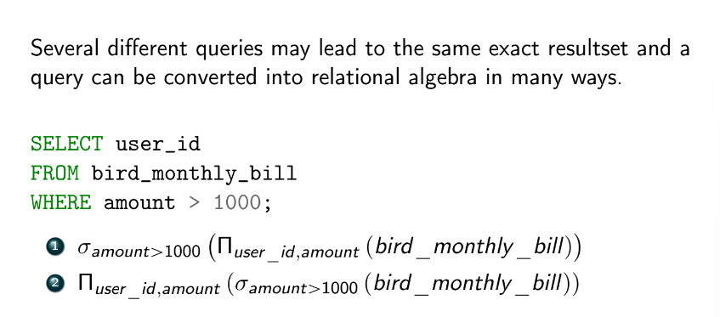
  + optimization -> a series of query-optimizing transformations
    - picks most efficient query plan
      * criteria:
        + # of block transfers and seeks
        + # of tuples
        + current CPU/RAM usage
        + data transfer speed
        + disk space
        + network transfer
        + time
  + evaluation -> an actual evaluation of queries
  + 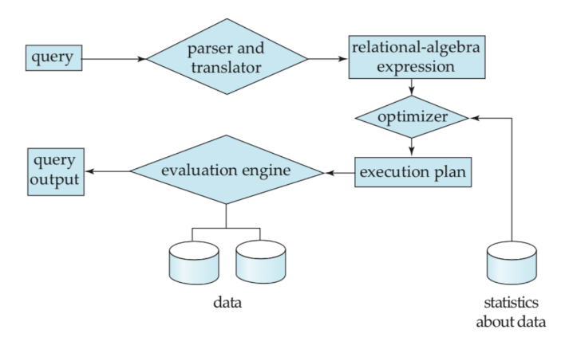
  + 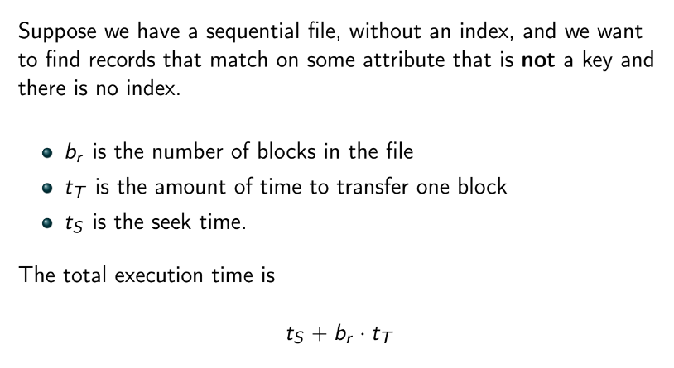
  + if blocks are not contiguous, we must seek for each block as well
    - tsbr + tTbr
* nested-loop join: given nr x ns pair of tuples, with br and bs being the number of blocks in R and S:
  + O(n^2)
  + number of block transfers: br + nrbs
  + number of seeks: br + nr
  + if one of the relations fits fully in memory, it should be in the inner loop
    - if R fits in memory:
      * if R is inner loop:
        + number of block transfers: bs + br
        + seeks: 2
      * if R is outer loop:
        + number of block transfers: br + nrbs
        + seeks: nr + 1
* block nested-join loop
  + number of block reads: br(bs + 1)
  + number of seeks: 2br
* indexed nested-join loop
  + 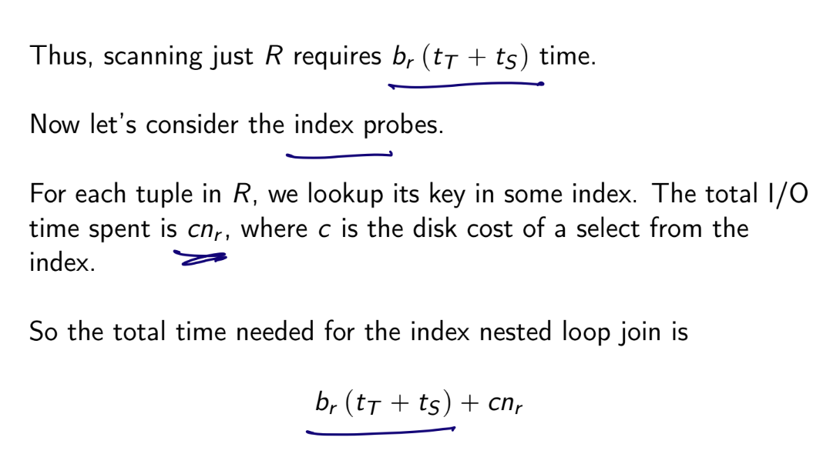
* merge join
  + R and S must be already sorted on some join key
  + number of block reads: br + bs
  + number of seeks: proportional to ceiling(br/bb + bs/bb)
    - bb: number of blocks that fit in buffer
* hash join
  + 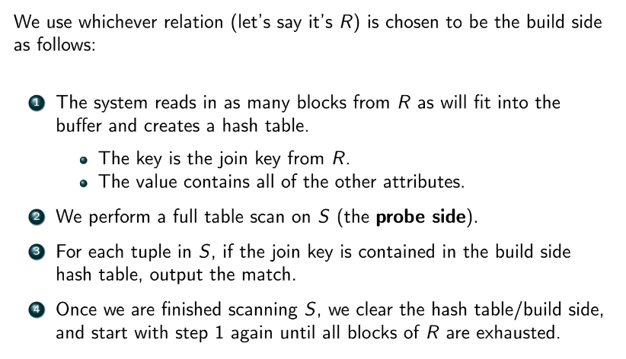
  + similar to block nested join loop
* indexed nested-loop, merge join, and hash join can only be used for simple join conditions (natural joins or equijoins)
* **Spark join algorithms**
  + shuffle based joins: if neither relation fits in RAM, we use this.
    - 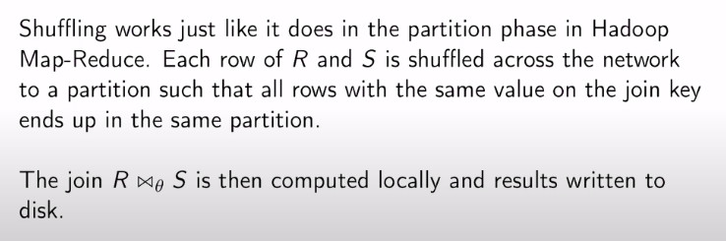
    - hash join
      * neither table needs to fit in RAM
      * doesn’t require keys to be sortable
      * only supports equijoins, cannot perform full outer join
      * shuffling is expensive, hash table uses more RAM
    - sort-merge join
      * keys must be sortable
      * susceptible to key skew
      * 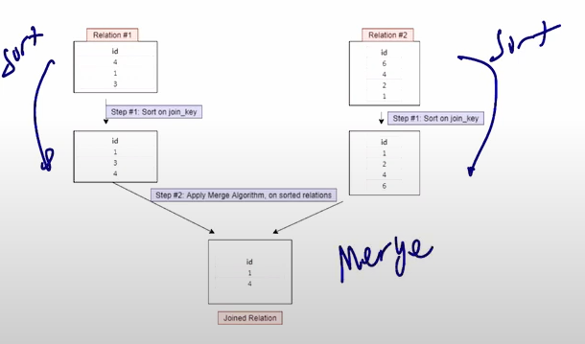
      * default join on Spark
    - explain() will show query plan in Spark
  + broadcast based joins: if one of the tables involved can fit entirely in RAM, the table is broadcasted to all executors in the cluster
    - broadcast nested-loop join: can handle all join types, typically least performant
    - broadcast hash join: only supports equijoins, cannot perform full outer join
  + 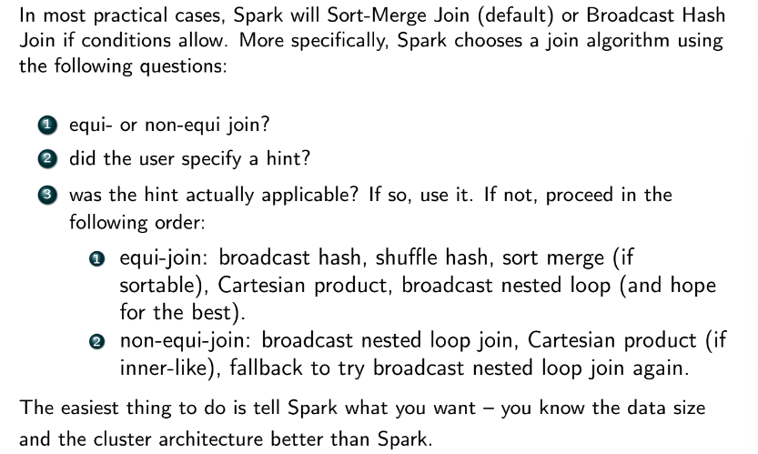
    - be explicit about broadcast join: 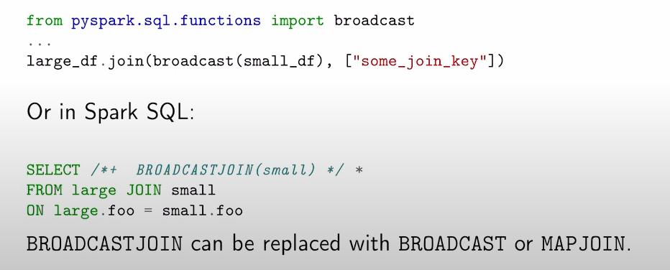

### Transactions

* START TRANSACTION

…

COMMIT;

* + Everything between START TRANSACTION and COMMIT happens atomically (all or nothing is executed)
* autocommit: when enabled, there’s an implied COMMIT after each statement
  + 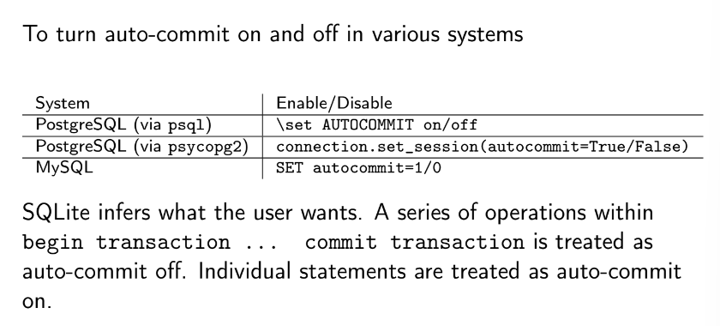
* 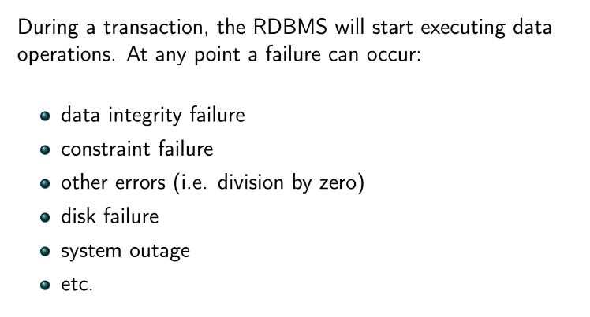
  + when an error occurs, the transaction stops and performs a **rollback** on the transaction
    - similar to journaled filesystem
  + partially committed: written to buffer but not yet disk
* 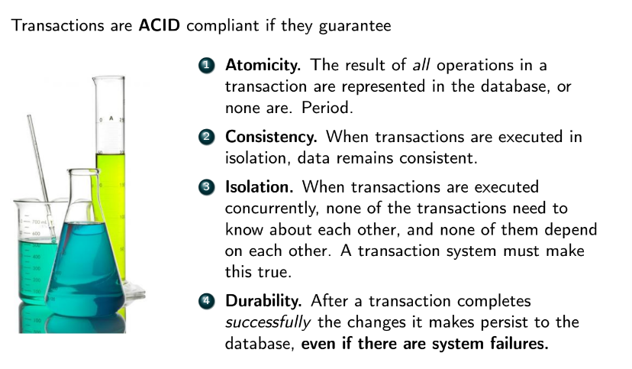
  + NoSQL cannot completely satisfy ACID
    - NoSQL satisfies ACID to varying degrees, some are fully ACID compliant as long as a transaction only touches one node
    - 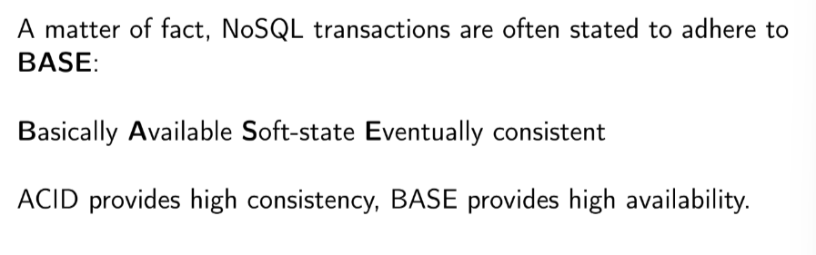
      * 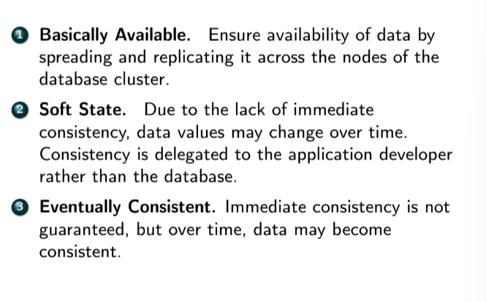
  + tradeoffs
    - high isolation = less concurrency = worse performance = better consistency
* serial schedules are always consistent
  + if a concurrent schedule provides same result as serial schedule, then the concurrent schedule is consistent
* serializability
  + given a concurrent schedule, if we are able to swap instructions in both transactions until both transactions occur serially, then we have **conflict serializability**. *This means that the concurrent schedule is guaranteed to achieve consistency*
    - read and read on the same datapoint can be swapped
    - write and read on the same datapoint cannot be swapped
    - write and write on the same datapoint cannot be swapped
  + 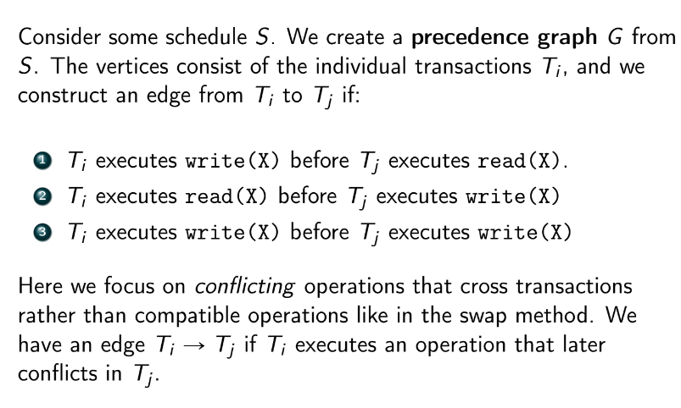
    - if a cycle forms in the graph, consistency is not guaranteed
    - otherwise, the schedule is conflict serializable
      * topo sort to get order of transactions in serial schedule that would give same result as current schedule
* **levels of isolation (strongest to weakest)**
  + serializable: schedule equivalent in result to a serial schedule
  + repeatable read: don’t allow Ti to write to X if Tj re-reads that value later
  + read committed: Ti can only read data from Tj that has been committed
  + read uncommitted: Ti can read any of Tj’s data even if it hasn’t been committed
* **dirty read**: when a transaction can read uncommitted changes from other transactions
* **non-repeatable/fuzzy read**: when one transaction read a value, then some other transaction overwrites that value and commits it, then the first transaction read the value again
* **phantom read**: when one transaction inserts or deletes rows on a table in between two fetches in another transaction
  + applies to changes to a set of records, not the existing records themselves
* 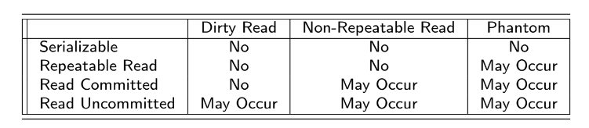
* Locking
  + two modes
    - shared: allows read access to X for transaction, but no writes, transaction can have multiple shared locks on X and multiple transactions can have s-lock on X
      * multiple transactions can hold a shared lock on the same data item
    - exclusive: allows R/W access
      * only one transaction can hold an exclusive lock at a time (if a transaction holds an exclusive lock on A, no other transaction can hold either an exclusive or shared lock on A)
  + if we unlock too early, we may lose serializability
  + if we unlock too late, we may get deadlock
  + **two phase locking protocol (2PL):**
    - growing phase: transaction can acquire locks but can’t release them
    - shrinking phase: transaction can unlock but cannot acquire more locks
    - ensures serializability
    - doesn’t prevent deadlock
  + **deadlock**
    - 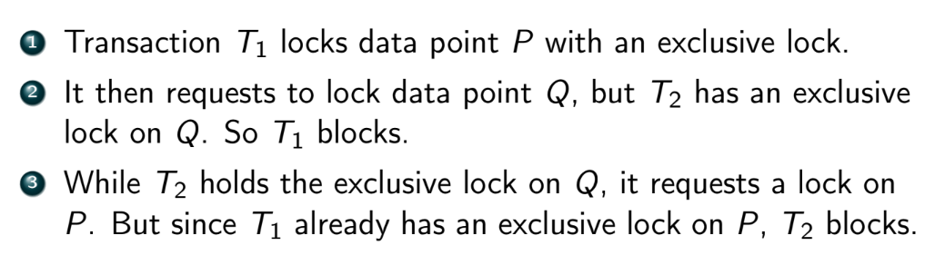
    - 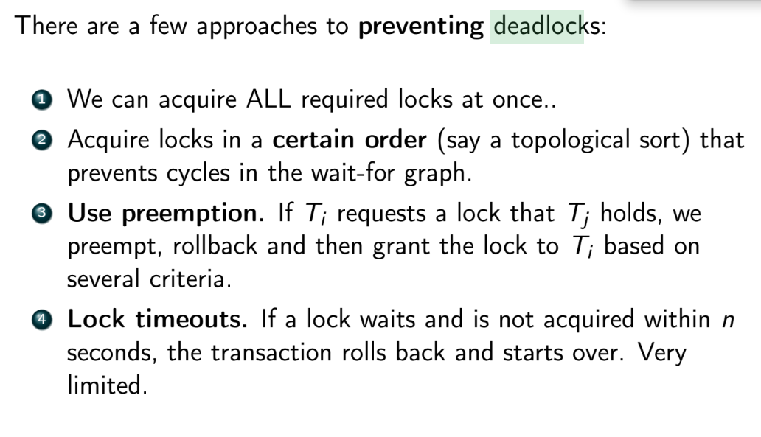
* Redis only truly supports isolation in ACID
* consistency and isolation of MongoDB has been disputed

### For exams:

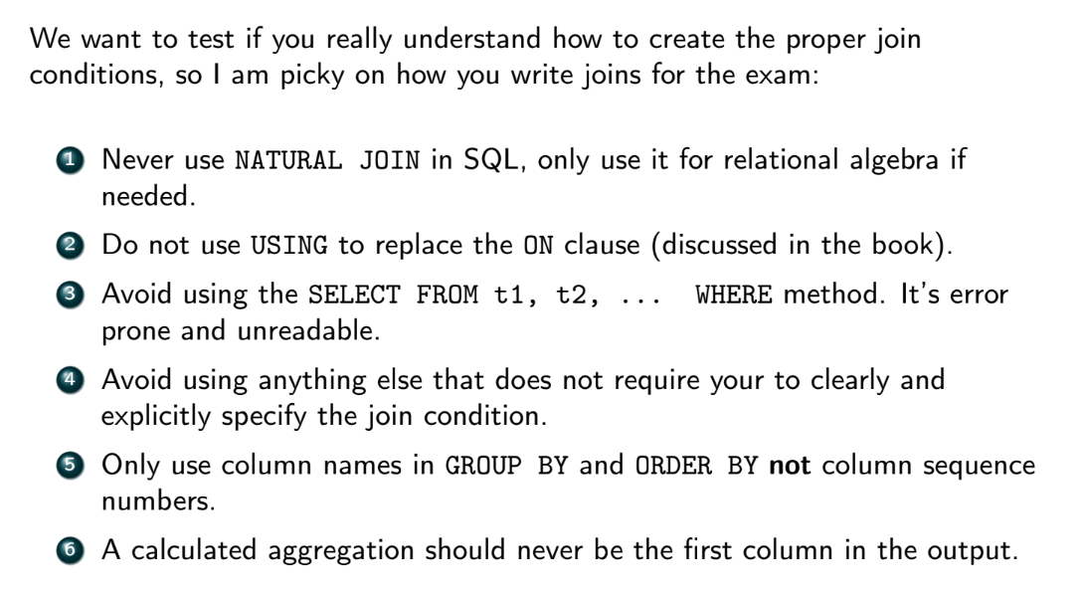

* Subqueries are sometimes unavoidable, but minimize the number of subqueries you use in your responses
  + if the problem involves HAVING, use it
  + do not use CTEs to avoid a subquery (no WITH)
* potential questions about functional dependencies
  + find FDs given table
  + use FDs to determine normal form
* enums:
  + 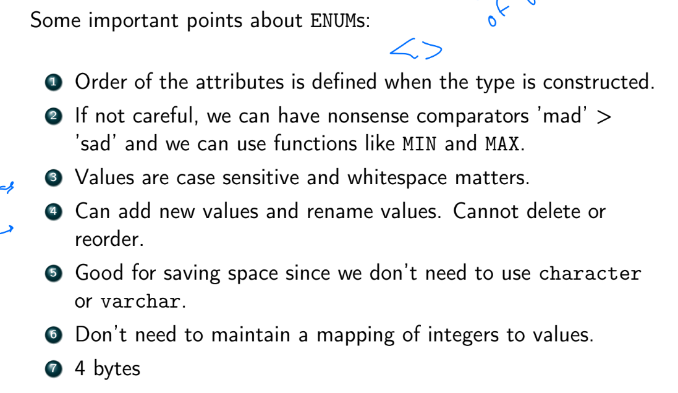
* 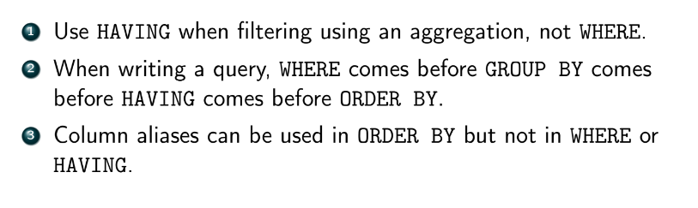

### Extra homework stuff

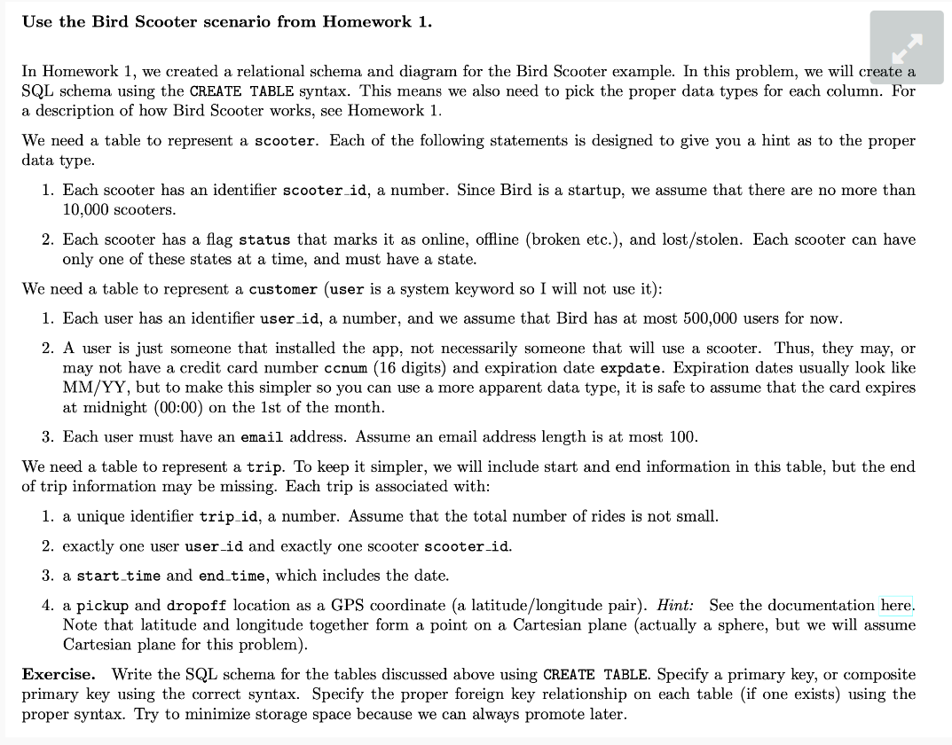

CREATE TYPE status_setting AS ENUM ('online', 'offline', 'lost/stolen');

CREATE TABLE scooter (

scooter_id smallint,

status status_setting NOT NULL,

PRIMARY KEY (scooter_id)

);

CREATE TABLE customer (

user_id integer,

ccnum numeric(16),

expdate date,

email varchar(100) NOT NULL,

PRIMARY KEY (user_id)

);

CREATE TABLE trip (

trip_id bigint,

user_id integer NOT NULL,

scooter_id smallint NOT NULL,

start_time timestamptz NOT NULL,

end_time timestamptz,

pickup point NOT NULL,

dropoff point,

PRIMARY KEY (trip_id),

FOREIGN KEY (user_id) REFERENCES customer(user_id),

FOREIGN KEY (scooter_id) REFERENCES scooter(scooter_id)

);

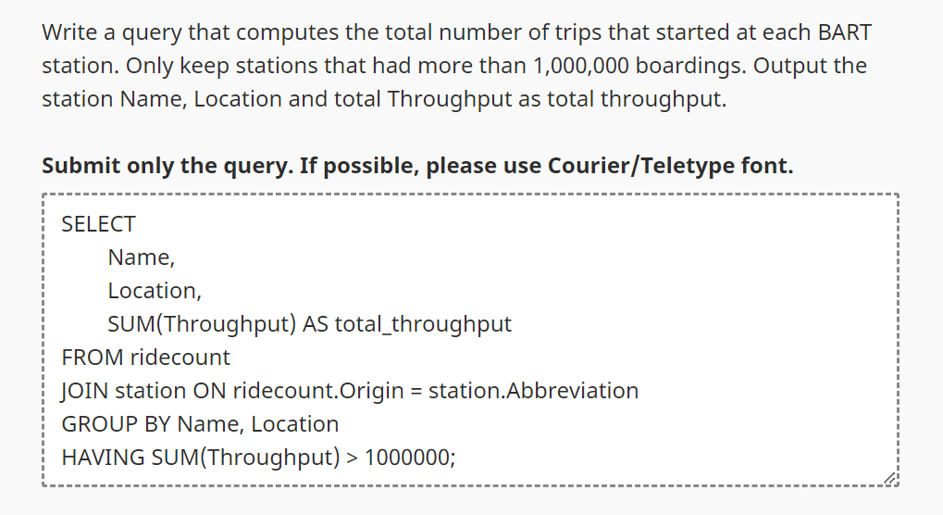

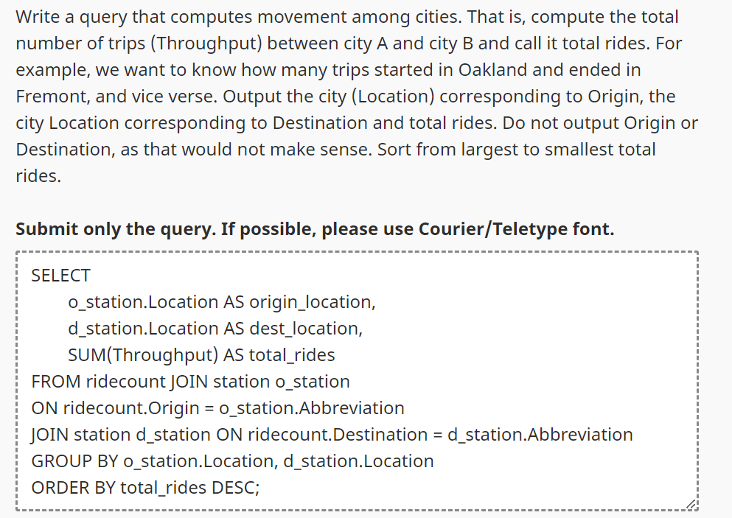

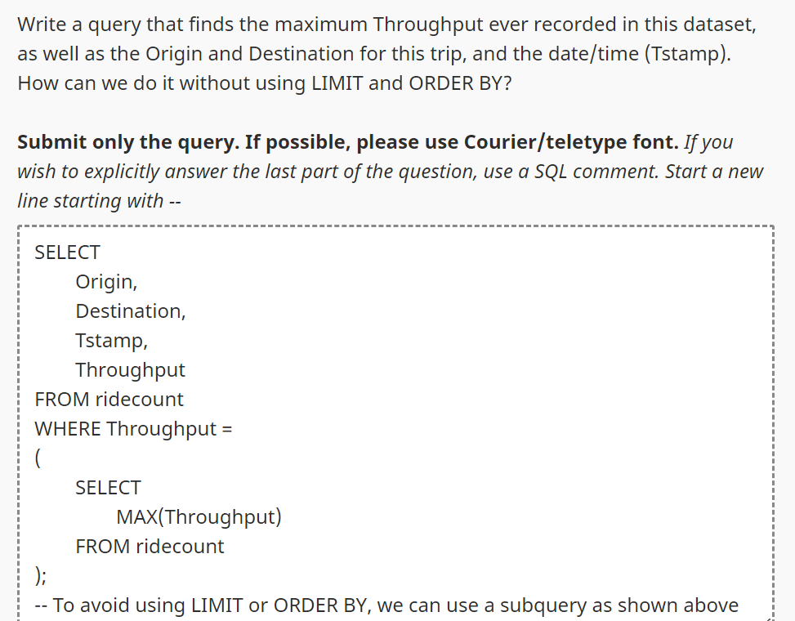

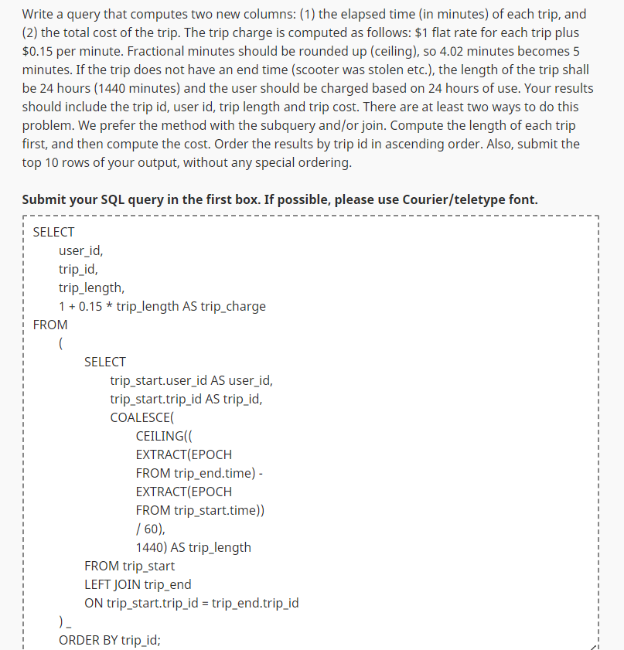

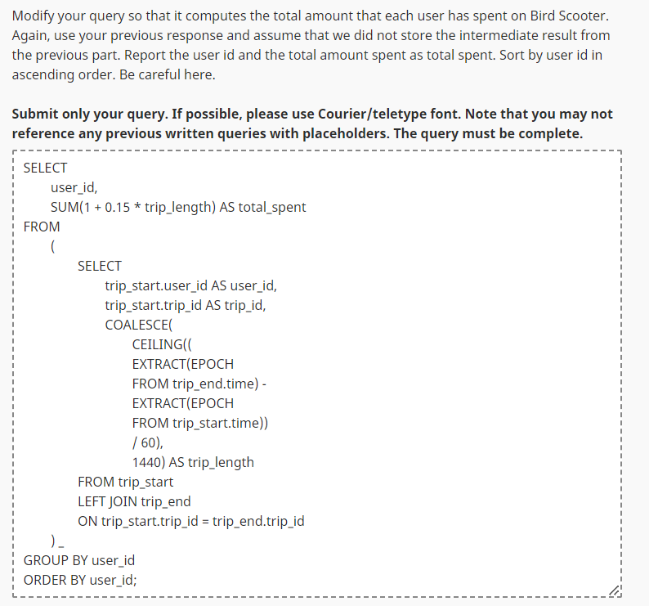

* EXISTS, NOT EXISTS, EXCEPT, IN, NOT IN
  + Exists:
  + 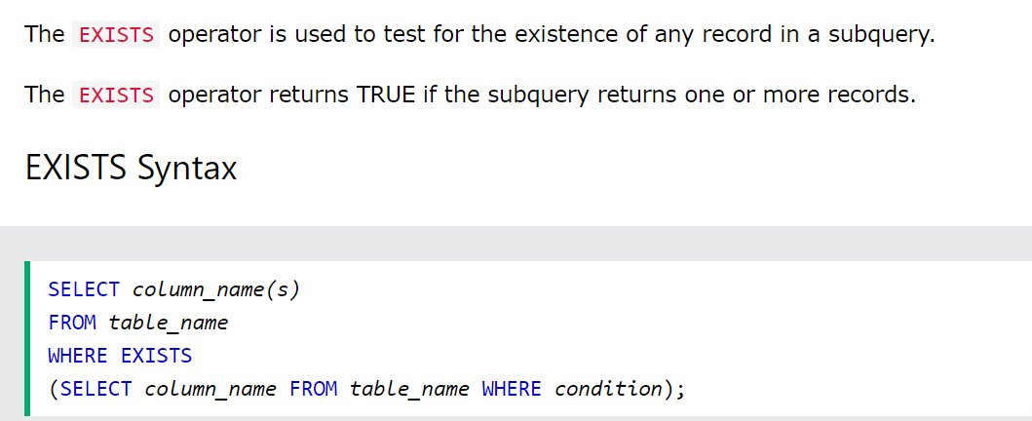
  + Except:
    - The SQL EXCEPT statement returns those records from the left SELECT query, that are not present in the results returned by the SELECT query on the right side of the EXCEPT statement.
    - 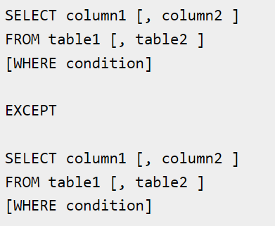
  + In:
  + 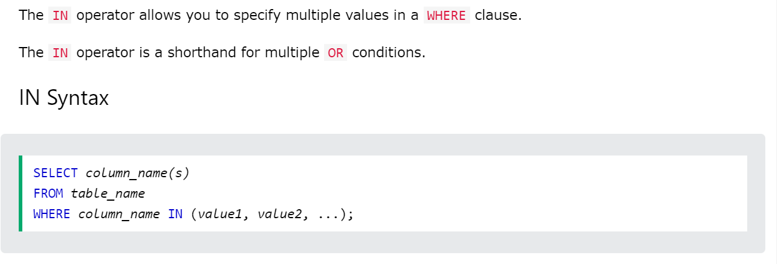

### Redis Demo

# Set a key

SET foo 1

# Increment the value

INCR foo (good for counters)

GET foo

# Retrieve a missing key.

GET bar

# Increment by another value

INCRBY foo 100

GET foo

# Expire this key/value pair after 1 hour.

EXPIRE foo 60 # Great for caching.

# Does the key exist?

EXISTS foo (returns 1 or 0)

# Get the value for key

GET foo

# Set values for multiple keys

MSET bar 42 baz 11

# Get values for multiple keys.

MGET bar baz # (nil) is none

# Let's check up on our cached key.

GET FOO

##### Strings

# Create a key/value pair, where value is a string.

SET username ryanrosario

GETRANGE username 4 11 # indexed from 0. Same as SUBSTR

APPEND username _teaches_cs143

GET username

STRLEN username

# List values.

# Doesn't have to be defined beforehand

LPUSH words man

LPUSH words woman

LPUSH words person

RPUSH words camera

RPUSH words tv

$ Get the list length.

LLEN words

# Get the words in order.

LRANGE words 0 4

# Pop from either side of the list. Can use as a dequeue, queue or stack.

LPOP words

RPOP words

RPOP words

RPOP words

RPOP words

RPOP words # no error

# Sets

# Tropical fruits in smoothie 1

SADD fruits1 coconut

SADD fruits1 pineapple guava avocado

# Tropical fruits in smoothie 2

SADD fruits2 pitaya orange guava pineapple

# What fruits are in both?

SINTER fruits1 fruits2

# What fruits do I need to buy to make both?

SUNION fruits1 fruits2

# Shopping list

SUNIONSTORE shopping fruits1 fruits2

# Get all members

SMEMBERS shopping

# Get a random set element

SRANDMEMBER shopping

# Create a hash (dictionary)

HSET professor firstname ryan lastname rosario university ucla

HGET professor university

# List all the keys

KEYS *

# Delete some keys we created

DEL foo username counts fruits

# Clean up

FLUSHDB

FLUSHALL

### MongoDB Demo

/*CS143 - WINTER 2023 - LECTURE 13 - MONGODB DEMO

To install MongoDB, follow the directions below:

https://docs.mongodb.com/manual/installation/

BASIC CRUD (WITHOUT THE R)

*/

show dbs

use demo // doesn't need to already exist

show collections

//Insert one record

db.cs22SCourses.insertOne(

{

code: "CS 143",

title: "Data Management Systems", // String

lec_days: ["M", "W"], // Array

time_from: 16,

time_to: 18,

professor: {

name: "Rosario, R. R.",

email: "rrosario@cs.ucla.edu"

},

ta: ["Tyler", "Song", "Vivian"],

}

);

// Add two graders.

// Add a TA to the TA array.

db.cs22SCourses.updateOne(

{ code: "CS 143" },

{

$set: {

grader: ["Madhav", "Nicole"]

},

$push: { ta: "Hughes" }

}

);

db.cs22SCourses.insertMany([

{

code: "CS 130",

professor: ["Burns, M.", "Hyman, J."]

},

{

code: "CS 111"

}

]);

// Delete CS 111.

db.cs22SCourses.deleteOne({

code: "CS 111"

});

db.cs22SCourses.deleteMany({});

/* YELP QUERYING DEMO

Though we will try to create a Docker container for you, especially if there is a

homework using it.

Then open mongodb shell by typing "mongo".

Create the Yelp database

*/

use yelp

show collections

db.business.explain()

// What does a Yelp business record look like?

> db.business.findOne({ categories: {$regex: "Restaurants" } })

{

"_id" : ObjectId("60b540bdd8f924bd13670997"),

"business_id" : "NDuUMJfrWk52RA-H-OtrpA",

"name" : "Bolt Fresh Bar",

"address" : "1170 Queen Street W",

"city" : "Toronto",

"state" : "ON",

"postal_code" : "M6J 1J5",

"latitude" : 43.6428886,

"longitude" : -79.4254291,

"stars" : 3,

"review_count" : 57,

"is_open" : 1,

"attributes" : {

"WiFi" : "u'no'",

"BikeParking" : "True",

"RestaurantsPriceRange2" : "2",

"BusinessParking" : "{'garage': False, 'street': True, 'validated': False, 'lot': False, 'valet': False}",

"RestaurantsTakeOut" : "True",

"Caters" : "False"

},

"categories" : "Juice Bars & Smoothies, Food, Restaurants, Fast Food, Vegan",

"hours" : {

"Monday" : "8:0-21:0",

"Tuesday" : "8:0-21:0",

"Wednesday" : "8:0-21:0",

"Thursday" : "8:0-21:0",

"Friday" : "8:0-21:0",

"Saturday" : "9:0-21:0",

"Sunday" : "9:0-21:0"

}

}

/* Can search a range using:

field : { $gte: value, $lte: value} */

// Let's retreive all Starbucks, their states and ratings.

db.business.find({

name: "Starbucks",

}, {

name: 1,

state: 1,

stars: 1,

_id: 0

});

// To make it a "non equal", we can replace name: "Starbucks" with name: { $ne: "Starbucks" }

// Let's retrieve all Indian, Mexican or Italian restaurants that are either

// casual attire or takeout (if it's not casual attire, I will take the food out).

// Additionally, if I sit inside, there should be free Wifi.

db.business.find({

$or: [

{ "attributes.RestaurantsAttire": "'casual'",

"attributes.WiFi": "'free'" },

{ "attributes.RestaurantsTakeOut": "True" }

],

categories: {$contains: "Restaurants"},

categories: {$regex: "Indian|Italian|Mexican"},

}, {

name: 1,

categories: 1,

stars: 1,

state: 1,

_id: 0

}).sort( { stars: -1 } );

// Average rating for Starbucks in the USA and Canada (which has the state field).

db.business.aggregate(

[

{

$match: {

name: "Starbucks"

}

},

{

$group: {

_id: "$state",

average: { $avg: "$stars" }

}

}

]

);

/* First Stage: The $match stage filters the documents by the name field

and passes to the next stage those documents that have name equal

to "Starbucks".

Second Stage: The $group stage groups the documents by state field to calculate

the average star rating.

*/

### Neo4j Cypher Demo

// Show entire graph

MATCH (n) RETURN n

// Find all moves made in the 90s.

MATCH (nineties:Movie) WHERE nineties.released >= 1990 AND nineties.released < 2000 RETURN nineties.title

// Find Tom Hanks movies that he acted in. Returns a Person node called tom,

// which is Tom Hanks info. The unknown result is called tomHanksMovies which

// must be of type Movie because :ACTED_IN always point Person->Movie

// Get the movie title, year it was released and his role in the movie.

MATCH (tom:Person {name: "Tom Hanks"})-[r:ACTED_IN]->(tomHanksMovies) RETURN tomHanksMovies.title, r.roles, tomHanksMovies.released

// What about roles he played?

// Who directed Cloud Atlas?

// cloudAtlas name isn't used. directors is the unknown result.

MATCH (cloudAtlas {title: "Cloud Atlas"})<-[:DIRECTED]-(directors) RETURN directors.name

// cloudAtlas:Movie is optional since there is only one node with title Cloud Atlas

// Tom Hanks' co-actors

// We want to find all Person nodes that point to some Movie m that Tom Hanks also

// points to as an actor. The unknown output is coActors.

MATCH (tom:Person {name:"Tom Hanks"})-[:ACTED_IN]->(m)<-[:ACTED_IN]-(coActors) RETURN coActors.name

// We don't need m:Movie because all PERSON-[:ACTED_IN]-> relationships yield a movie.

// What about all movies that Tom Hanks and Meg Ryan acted in?

// Find all people that worked on Cloud Atlas

// Returns a property of a Person node (name), the type of the relationship, and any

// any attributes

MATCH (people:Person)-[relatedTo]-(:Movie {title: "Cloud Atlas"}) RETURN people.name, Type(relatedTo), relatedTo

// Note here that we don't need m:Movie for example. We can just use :Movie because

// we never use any of the attributes of the Movie node.

// Find all movies AND people between 1 and 4 hops away from Kevin Bacon

// hollywood is unknown output.

MATCH (bacon:Person {name:"Kevin Bacon"})-[*1..4]-(hollywood)

RETURN DISTINCT hollywood

// What about only people that ACTED_IN movies?

// Shortest path from Kevin Bacon to Meg Ryan

MATCH p=shortestPath(

(bacon:Person {name:"Kevin Bacon"})-[*]-(meg:Person {name:"Meg Ryan"})

)

RETURN p